 Titration calculations
Specification references
- C3.4 Using concentrations of solutions in mol/dm3 
- MS 1a, 1c, 3b, 3c
- WS 4.2, 4.3, 4.6
Aims
This worksheet will give you practice in converting between numbers of moles, volume, and concentration. It will also give you practice in completing titration calculations.
Learning outcomes
After completing this worksheet, you should be able to:
- calculate the unknown concentration of a reactant in a neutralisation reaction when the volumes are known and the concentration of one reactant is also known.
Setting the scene
In an acid–base titration, the concentration of one solution is determined by finding out exactly how much of a second solution with a known concentration is needed to neutralise it.
In order to be able to successfully complete titration calculations you need to be confident in converting between the amount in moles, the volume of a solution, and the concentration of the solution, using the equation:
concentration (mol/dm3) = $\frac{\text{amount of substance }(\text{mol})}{\text{volume }({\text{dm}}^{3})}$
The important thing to note is that the volume of the solution must be given in units of decimetres cubed (dm3). 1 dm3 is equal to 1000 cm3 so to convert between the two units you need to multiply or divide by a factor of 1000. The diagram below will help you with this conversion:
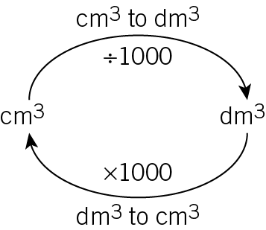
Worked example
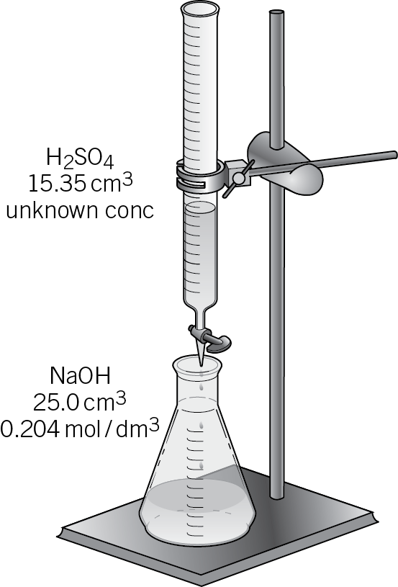
In a titration experiment, 25.0 cm3 of sodium hydroxide, NaOH, with a concentration of 0.204 mol/dm3 was transferred via pipette into a conical flask. Sulfuric acid, H2SO4, of unknown concentration was added by burette until the NaOH was neutralised. 15.35 cm3 of the solution of sulfuric acid was needed for neutralisation.
Calculate the concentration of the sulfuric acid.
Give your answer to three significant figures.
Step 1
First, sketch out a picture of the titration equipment
to help you visualise the process.

Step 2
Next, you need to calculate the amount of substance, in moles, of either the acid or the alkali where you know both the volume used and the concentration.
In this case, you know the concentration and volume of the alkali, NaOH.
To calculate the amount of NaOH in moles, you need to rearrange the equation below to make the ‘amount of substance’ the subject:
concentration (mol/dm3) = $\frac{\text{amount of substance }(\text{mol})}{\text{volume }({\text{dm}}^{3})}$
You do this by multiplying both sides by volume:
volume (dm3) × concentration (mol/dm3) = $\frac{\text{amount of substance }(\text{mol})}{\text{volume }({\text{dm}}^{3})}$ × volume (dm3)
The volumes on the right cancel out to give you:
volume (dm3) × concentration (mol/dm3) = amount of substance (mol)
Before you can substitute the volume of the NaOH into this rearranged equation, you need to convert its units into dm3.
To do this, divide the volume in cm3 by 1000:
$$\frac{\text{25}\text{.}{\text{0 cm}}^{3}}{\text{1000}}$$
= 0.025 dm3
You are now ready to calculate the amount of NaOH in moles:
amount of NaOH (mol) = 0.025 dm3 × 0.204 mol/dm3
= 0.0051 mol
Step 3
You then need to calculate the amount of H2SO4 in moles at neutralisation. Before you can do the calculation, you need to write a balanced symbol equation for the neutralisation reaction:
2NaOH + H2SO4 → Na2SO4 + 2H2O
Step 4
Now you can work out the amount of H2SO4 in moles that was required to neutralise the 0.0051 moles of NaOH.
From the balanced equation you know that 1 mole of H2SO4 neutralises 2 moles of NaOH.
Therefore, the amount of H2SO4 required to neutralise 0.0051 moles of NaOH is:
0.0051 ÷ 2 = 0.00255 moles.
Step 5
Finally, you can calculate the concentration of the H2SO4 solution.
You know that the 0.00255 moles of H2SO4 required to neutralise the NaOH was contained in 15.35 cm3 of the solution. Therefore, you can calculate the concentration of the H2SO4 by dividing the amount in moles by its volume.
Once again, the volume in cm3 first needs to be converted to dm3:
$$\frac{\text{15}\text{.}{\text{35 cm}}^{3}}{\text{1000}}$$
= 0.01535 dm3
Now you can calculate the concentration of the H2SO4 using the equation from above:
concentration (mol/dm3) = $\frac{\text{amount of substance }(\text{mol})}{\text{volume }({\text{dm}}^{3})}$
= $\frac{0\text{.}\text{00255 mol}}{0\text{.}{\text{01535 dm}}^{3}}$
= 0.1661 mol/dm3
= 0.166 mol/dm3 (to 3 significant figures)
Questions
1 For each of the titration experiments described below, sketch a diagram to show which reagent is in the burette and which reagent is in the conical flask. Include in your diagram the concentration and volume of each reagent.
a 25.0 cm3 of a solution of sodium hydroxide, NaOH, with a concentration of 0.115 mol/dm3 was transferred via pipette into a conical flask. Hydrochloric acid, HCl, of unknown concentration was added from a burette until neutralisation. 12.00 cm3 of the hydrochloric acid, HCl, was needed for neutralisation. (2 marks)
b 25.0 cm3 of a solution of sodium hydroxide, NaOH, with an unknown concentration was transferred via pipette into a conical flask. Hydrochloric acid, HCl, with a concentration of 0.128 mol/dm3 was added from a burette until neutralisation. 35.20 cm3 of the hydrochloric acid, HCl, was needed for neutralisation. (2 marks)
c In a titration experiment, 16.85 cm3 of a solution of sodium hydroxide, NaOH, with a concentration of 0.108 mol/dm3 was needed to neutralise exactly 20.0 cm3 of sulfuric acid, H2SO4, with an unknown concentration. (2 marks)

2 a Calculate the amount in moles in each of the following solutions:
i 0.0350 dm3 of a solution with a concentration of 0.108 mol/dm3 (1 mark)
ii 41.8 cm3 of a solution with a concentration of 0.0501 mol/dm3 (2 marks)
b Calculate the concentration of each of the following solutions:
i 0.0250 dm3 of a solution that contains 0.345 mol of substance (1 mark)
ii 18.90 cm3 of a solution that contains 0.480 mol of substance (2 marks)

3 In a titration experiment, 20.0 cm3 of sodium hydroxide, NaOH, with an unknown concentration was placed in a conical flask. 25.10 cm3 of a solution of hydrochloric acid, HCl, with a concentration of 0.128 mol/dm3 was needed for neutralisation.
Give all your answers to the relevant questions below to three significant figures.
a Sketch a diagram to show the titration set up at the point neutralisation is reached. (2 marks)
b Calculate the amount in moles of HCl in 25.10 cm3 of a solution with a concentration of 0.128 mol/dm3. (2 marks)
c Write an equation for the neutralisation reaction between HCl and NaOH. (1 mark)
d Use your answer to parts b and c to determine the amount of NaOH in 20.0 cm3 of NaOH that is exactly neutralised by the HCl. (1 mark)
e Calculate the concentration of the NaOH solution in the conical flask.
(2 marks)

4 A student carries out a titration to determine the concentration of a solution of nitric acid. She titrates the solution of nitric acid against a standard solution of sodium hydroxide with a known concentration of 0.0998 mol/dm3. She finds that 21.80 cm3 of the nitric acid solution is needed to exactly neutralise 25.0 cm3 of the sodium hydroxide solution.
Calculate the concentration of the nitric acid solution. Give your answer to three significant figures.
The equation for the neutralisation reaction is
HNO3 + NaOH → NaNO3 + H2O
(4 marks)
5 A student used a pipette to add 25.0 cm3 of KOH of unknown concentration to a conical flask.
The student carried out a titration experiment to find the volume of 0.150 mol/dm3 H2SO4 needed to neutralise the KOH.
The student found that, on average, 17.20 cm3 of the H2SO4 solution was required for neutralisation.
a Write a balanced symbol equation for the neutralisation reaction between H2SO4 and KOH. (1 mark)
b Calculate the concentration of the KOH solution. (5 marks)
Maths skills links
You will also need to be able to convert between volumes that use different units, and to be able to rearrange equations, when calculating the amounts of substances in equations and the volumes of gases.

