Chemical Energy Study Questions

1. Calculate the standard enthalpy of combustion for the following reaction:

C6H12O6 (s) + 6 O2 (g) 🡪 6 CO2 (g) + 6 H2O (l)  
  
To solve this problem, we must know the following ΔH°f values:

|  |  |
| --- | --- |
| C6H12O6 (s) | -1275.0 |
| O2 (g) | zero |
| CO2 (g) | -393.5 |
| H2O (l) | -285.8 |

1. Ammonia reacts with oxygen to form nitrogen dioxide and steam, as follows:

4 NH3(g) + 7 O2(g) 🡪 4 NO2(g) + 6H2O(g)

Given the following standard enthalpies of formation (given in kJ/mol):

|  |  |
| --- | --- |
| NH3(g) | -45.90 |
| NO2(g) | +33.1 |
| H2O(l) | -241.83 |

Calculate the enthalpy of the reaction.

1. Use the data booklet to calculate ΔH for the combustion of butane gas, C4H10, to produce gaseous carbon dioxide and liquid water.  
     
   2C4H10(g) + 13O2(g) 🡪 8CO2(g) + 10H2O(l)

1. Calculate the enthalpy change for the reaction

C2H4(g) + H2(g) 🡪 C2H6(g) ΔH = ?

Given:

C2H4(g) + 3O2(g) 🡪 2CO2(g) + 2H2O(l) ΔH = -1410.9kJ

2C2H6(g) + 7O2(g) 🡪 4CO2(g) + 6H2O(l) ΔH = -3119.4kJ

2H2(g) + O2(g) 🡪 2H2O(l) ΔH = -571.6kJ

1. The enthalpy of combustion of ethene relates to which of the following equations?
2. C2H4(g) + 202(g) 🡪 2CO2(g) + 2H2(g)
3. C2H4(g) + 302(g) 🡪 2CO2(g) + 2H2 O(l)
4. C2H4(g) + 202(g) 🡪 2CO(g) + 2H2O(l)
5. C2H4(g) + 02(g) 🡪 2CO(g) + 2H2(g)

1. Benzene can be produced from ethyne. The equation for this reaction is

3C2H2(g) 🡪 C6H6(l)

The enthalpy change for this reaction in kJ mol-1, using enthalpies of combustion from the data booklet, is

1. 632
2. -632
3. 1968
4. -1968



|  |  |  |
| --- | --- | --- |
| Reactant | Hydrochloric acid | Ammonia solution |
| Concentration/moll-1 | 1.0 | 2.0 |
| Volume/cm3 | 40.0 | 20.0 |
| Temperature/ °C | 20.5 | 20.5 |

The highest recorded temperature after mixing these solutions was 28.5 °C.

Use the data given to calculate the enthalpy of neutralisation of hydrochloric acid by ammonia solution. Ammonia solution, NH3(aq), reacts as NH4OH(aq) when it neutralises an acid. The equation for the reaction with hydrochloric acid is

NH4OH(aq) + HCl(aq) 🡪 NH4Cl(aq) + H2O(l)

1. A polystyrene cup contained 50cm3 of water at 21.2°C. A sample weighing 2.53g of powdered ammonium chloride was added and dissolved with stirring. Calculate the lowest temperature which the solution should reach given that the enthalpy of the solution of NH4Cl is 15.0 kJ mol -1.

1. The following results are taken from the notebook of a pupil who was trying to confirm Hess’s Law.

Experiment 1- Addition of 1.6g of sodium hydroxide solid to 50cm3 of 1 moll-1 hydrochloric acid

NaOH(s) + HCl(aq) 🡪 NaCl(aq) + H2O(l)

Mass = 50g

Initial temperature of HCl(aq) = 21. 7°C

Highest temperature during experiment = 29.9°C

ΔT = 8.2°C

Experiment 2- Addition of 25cm3 of 2moll-1 sodium hydroxide solution to 25cm3 of 2moll-1 hydrochloric acid

NaOH(aq) + HCl(aq) 🡪 NaCl(aq) + H2O(l)

Mass =50g

Initial temperature of HCl(aq) –T1 = 21.7°C

Initial temperature of NaOH(aq) –T2  = 22.1°C

Highest temperature during experiment = 28.6°C

ΔT =

1. i) In experiment 1, calculate which reactant is in excess (Show your working clearly)

ii) In experiment 1, calculate the enthalpy change during the reaction. You may wish to use the data booklet to help you.

1. Calculate ΔT for experiment 2

1. Suggest a precaution which should be taken to minimise heat loss during the experiments.
2. The equation for the formation of benzene from carbon and hydrogen is as follows:

6C(s) + 3H2(g) 🡪 C6H6(l)

Use enthalpies of combustion from your data booklet to calculate the enthalpy of this reaction.

1. The equation for the complete hydrogenation of ethyne to ethane is shown below:

C2H2(g) + 2H2(g) 🡪 C2H6(g)

The structure of ethyne is as shown below.

H—C≡C—H

The structure of ethane is:  
  
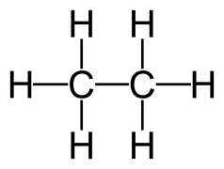

Calculate the enthalpy change of this reaction using

1. Enthalpies of combustion

1. Bond enthalpies

1. Use bond enthalpies to calculate the enthalpy change for this reaction:

N2(g) + 3H2(g) 🡪 2NH3(g)

1. **Ketones** exist in equilibrium with an **enol** isomer.

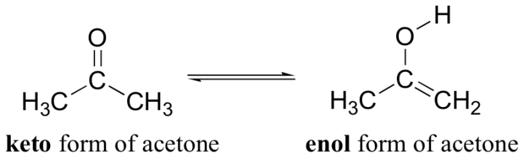

Use the bond energies in your data booklet to calculate the enthalpy change in kJmol-1 when one mole of gaseous acetone is converted to one mole of its gaseous enol isomer.

1. The enthalpy changes for the formation of one mole of aluminium oxide and one mole of iron (III) oxide are shown below.

2Al(s) + 1½O2(g) ⭢ Al2O3(s) ∆H = ─1676kJmol-1

2Fe(s) + 1½O2(g) ⭢ Fe2O3(s) ∆H = ─825kJmol-1

Use the above information to calculate the enthalpy change for the reaction, in kJmol-1 :

Al(s) + ½Fe2O3(s) ⭢ ½Al2O3(s) + Fe(s)

1. 4g of potassium chloride, KCl, was dissolved in 50cm3 of water. The initial temperature of the water was 20.4oC and the highest temperature of solution was 18.8oC.

Calculate the enthalpy of solution.

1. A 3.03g sample of potassium nitrate, KNO3, was dissolved in 100cm3 of water. The initial temperature of the water was 17.5oC and the highest temperature of solution was 15oC.

Calculate the enthalpy of solution.

1. A 250ml solution of 2.25moldm-3 HCl was neutralised by 250ml of NaOH solution. The temperature increased by 33oC. Calculate the enthalpy of neutralisation.
2. Calculate the enthalpy change for the following reaction:  
     
   enthalpy of formation of ammonia to be -45.9kJmol-1, the enthalpy of formation of nitrogen monoxide 90.29kJmol-1 and the enthalpy of formation of water to be -285.83kJmol-1.
3. Calculate the enthalpy change for the combustion of propane:  
     
   -285.83 kJ/mol
4. Calculate the enthalpy change for the combustion of propane if 33g of propane (C3H8) were used.
5. Calculate the enthalpy change for the complete combustion of carbon using the equations:
6. Find the ΔH of:  
    ΔH = -537 kJ  
    ΔH = +52 kJ  
     
    ΔH = +680 kJ
7. Find the ΔH of:  
    ΔH = -298 kJ  
    ΔH = +198 kJ
8. Calculate the ΔH for the following reaction, using average bond enthalpies, assuming all compounds are in their gaseous states:  
     
     
   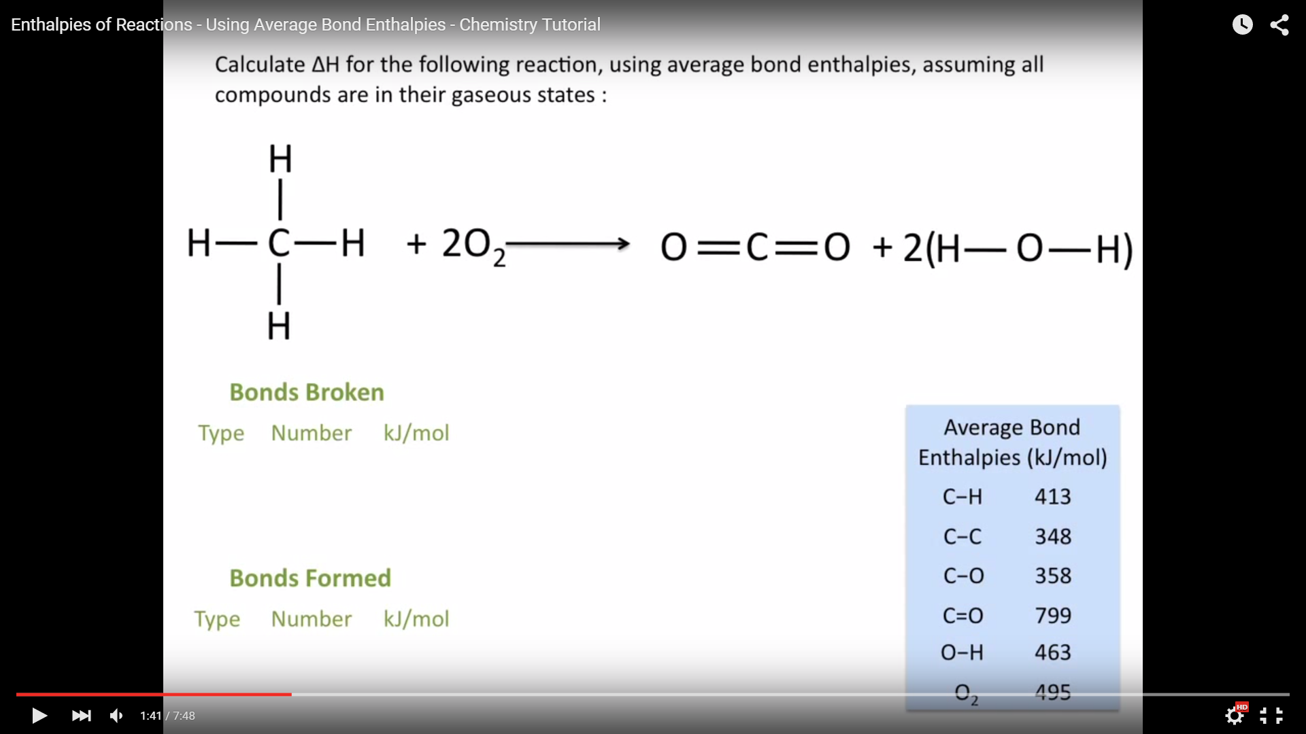
9. Calculate ΔH for the following reaction, using average bond enthalpies, assuming all compounds are in their gaseous states:  
     
   