

­­

Contents TBC

PART 1 - An introduction3

PART 2 – What’s involved in the units selected?4

Part 3 – HNC COACHING & THEORY 24/25……………………………………………………………………….…………………………………………………………………………………………………….31

PART 4 – Evidence grid example 39

PART 5 – Moodle page structure example………. …………………….….………………………………………………………………………………………………………………………………………….40

PART 6 – APPENDIX………………………………………………………………………………………………………………………………………………………………………………………………….………41-53

**PART 1 – AN INTRODUCTION**

Throughout the HNC year of sports coaching (Games & Sports / Football studies) courses at Glasgow Kelvin College, one of the main intentions is for learners to plan, deliver and review coaching practice with purpose. To help support the learner journey, a selection of units form a coaching and theory exclusive moodle page site. The units are listed below:

* **Developing professional practice (J2AW34)**
* **Psychology of sport & exercise (J42234)**
* **Inclusive sport & physical activity for participants with disabilities (J42334)**
* **Knowing others (J2AS34)**
* **Knowing yourself (J2AT34)**
* **Knowing coaching (J2AR34)**

Different outcomes and tasks from these units have been allocated to PLAN / DO / REVIEW phases throughout the academic year. Each phase requires learners to complete a variety of different modules prior to moving on to the next. Each module title is based on essential factors learners will consider from both coach and participant perspectives when working in industry.

Throughout delivery of the six units there are opportunities to integrate and combine unit components to streamline teaching and learning experiences. Where integrations have been suggested or units are delivered in isolation has been documented in the section is communicated within the assessment evidence section(s) below.

**PART 2 – What’s involved in the units selected?**

***\*Included in this section is the title of each unit, the knowledge & skills (K&S) for each outcome as well as the evidence required throughout. The blue hyperlink available next to each unit code takes the read directly to the official unit descriptor.***

**Developing professional practice (J2AW34) -** J2AW34 (1).pdf

|  |  |
| --- | --- |
| **LO1 K&S part (a-e)** | ***Understand the factors involved in providing a safe sports coaching environment.***  Knowledge and/or skills In relation to the following groups:  coaches; participants; safeguarding officer; volunteers; facility staff; parents/guardians; spectators; officials and key agencies including Sports Governing Bodies (SGBs):   * a) Responsibilities and the role of those involved in providing safe environments * b) Policy, procedures, facilities and resources in relation welfare needs and how to apply them * c) The impact of conduct, relationships and behaviours and how to manage them * d) Principles of providing a safe coaching environment — safeguarding vulnerable groups: — define safeguarding and its importance — understand legislation relating to safeguarding — identify factors that contribute to a safe environment — recognise signs of abuse — identify how to respond to a safeguarding situation — understand procedures to report and record observations * e) How to carry out a risk assessment: — understanding client group and associated risks — environmental risk factors: internal and external — equipment risk factors: checks; size and type of equipment |
| **LO2­ K&S (a-c)** | ***Understand industry legislation and guidance in sports coaching and development contexts.***  Knowledge and/or skills   * a) Legislative factors: — codes of conduct — current policy, legislation, procedures — health and safety legislation associated with sports coaching and development — reporting of incidents and accidents — data protection (GDPR) — equality and inclusion (includes disability) — liability and negligence guidelines — duty of care — standard of care, to include competence and integrity — types of insurance relevant to sports coaching and development * b) Workplace Policy and Procedures: — guidelines surrounding lone working — social media: safe and appropriate practice and digital footprint — guidelines for transport and travel of participants — handling complaints — emergency procedures * c) Professional and Personal Standards: — codes of conduct (as per guidelines for Code of Practice for Sports Coaches — UK Coaching) — Code of Ethics for Sports Coaching — recognition and awareness of mental health issues surrounding athletes and coaches — importance of continuing professional development — issues surrounding drugs and doping. |
| **LO3 K&S (a-b)** | Apply industry legislation and guidance in sports coaching and development contexts. Knowledge and/or skills   * Identify and follow policy and procedures in sports coaching and development environments * b) Recognise and adopt best practice in coaching environment |
|  |  |
| **LO123 Assessment evidence requirements** | **Assessment 1 —** Principles of providing a safe coaching environment Evidence will cover all of the following groups: coaches; participants; safeguarding officer; volunteers; facility staff; parents/guardians; spectators; officials and key agencies including Sports Governing Bodies (SGBs).   * Evidence will also cover: ω responsibilities and the role of those involved in providing safe environments. ω policy, procedures, facilities and resources in relation welfare needs and how to apply them. ω the impact of conduct, relationships and behaviours and how to manage them. Evidence will cover all of knowledge and skills items from Principles of providing a safe coaching environment. * The assessment will comprise objective questions which will contain a minimum of five questions for each of the six areas listed under the knowledge and/or skills item Principles of providing a safe coaching environment — safeguarding vulnerable groups. Learners will need to achieve a minimum 80% to pass this assessment. If a learner does not achieve the minimum 80% pass in each of the six areas, re-assessment is only required for the section(s) not achieved. |
|  | **Assessment 2 & 3**  Learners will produce one risk assessment within a sporting environment/context. Evidence must cover the three areas listed under the knowledge and/or skills item How to carry out a risk assessment. Outcomes 2 and 3 Learners will need evidence to show they can provide an accurate and clear response to two from four case studies relating to legislative factors, workplace policy and procedure, and professional and personal standards. Evidence must cover at least half of the areas listed under each of the three knowledge and/or skills items in Outcome 2. This assessment will be in the form of case studies. Learners will select and complete one case study (from two) per section. Section 1 — Scenarios will focus on legislative factors and workplace policy and procedures. Section 2 — Scenarios will focus on professional and personal standards. In advance of the assessment, learners will be given a copy of the case studies, to encourage independent study. Assessment questions will not be issued at this stage. Learners may bring a copy of the case studies to the assessment along with any notes they have made, not exceeding two A4 sheets of paper. Their notes will be collected by the assessor at the end of the assessment. Textbooks, handouts or other materials, not prepared by the learner will not be permitted. Each scenario will have 10 questions with a total of 20 marks. The minimum mark required to pass this assessment is a minimum 80% for each case study. If learners require to be re-assessed different case studies should be used.  It is recommended that learners complete a recognised safeguarding award during the delivery of this unit, eg sportscotland Child Wellbeing and Protection in Sport online award available the sportscotland website: National Governing Body safeguarding training. |

**PSYCHOLOGY OF SPORTS & EXERCISE -** J42234 (1).pdf

|  |  |
| --- | --- |
| **LO1 K&S (a-c)** | Discuss the main sport psychological components.   * a) Definition of sport psychology   - 1.1) What is sports psychology?  - 1.2) Why sport psychology is important.   * b) Definition of the components of sport psychology; (explain the below components / demonstrate an understanding of how they affect participant performance in either fitness / sports coaching environment)   - 1.1) anxiety  - 1.2) concentration  - 1.3) confidence  - 1.4) motivation  - 1.5) team cohesion   * c) Discuss the relationship between sport psychology components, participants & performance referring to the following:   - 1.1) Anxiety – theories that link arousal to performance such as ; drive theory, catastrophe theory, inverted U theory.  - 1.2) Concentration – attentional narrowing, attentional wastage, selective attention  - 1.3) Confidence – self efficacy theory  *(Explain why it is important as a practitioner to have knowledge & understanding of main components of sports psychology & relationship between sports psychology components, participants & performance). |
| **LO2 K&S (A – D)** | Describe methods designed to improve, enhance & manage sport & exercise psychological factors.   * A) Methods to enhance confidence. (x2 required) * B) Methods to manage anxiety. (x2 required) * C) Methods to improve concentration. (x2 required) * D) Methods to enhance team cohesion. (x2 required) |
| **LO3 K&S (A-C)** | Describe strategies for increasing participation & methods designed to enhance & manage motivation. (x2)   * A) Describe common motives for participation in sport & exercise * B) Describe behaviour modification techniques in relation to participation & motivation * C) Describe methods designed to enhance motivation in relation to participants performance. |
|  |  |
| **LO1 Assessment evidence requirements** | Outcome 1 — Discuss the main sport psychological components.   * a) What defines the term sport psychology? — What is sport psychology? — Why sport psychology is important. * b) Explain the main components of sport psychology and demonstrate an understanding of how these components affect participant performance in either a fitness or sports coaching environment. — anxiety — concentration — confidence — motivation — team cohesion * c) Explain why it is important as a practitioner to have knowledge and understanding of the main components of sport psychology and the relationship between sport psychology components, participants and performance. Learners will produce a piece of evidence covering the requirements as listed above in relation to their role in either a fitness or sports coaching environment**. Evidence generated should be supported by literary sources to illustrate the learner is capable of synthesising information from research.** |
| **LO2 Assessment evidence requirements** | Outcome 2 — Describe methods designed to improve, enhance, and manage sport and exercise psychological factors.   * Describe methods designed to enhance and the following sport psychological components in relation to participant/s performance: — a) managing anxiety — b) improving concentration — c) improving confidence — d) improving team cohesion. * Learners will produce evidence **covering two identified methods for each component to cover requirements as listed above. Evidence generated should be supported by literary sources to illustrate the learner is capable of synthesising information from research.** |
| **LO3 Assessment evidence requirements** | Outcome 3 — Describe strategies for increasing participation and methods designed to enhance and manage motivation. Describe strategies for increasing participation and methods designed to enhance and manage motivation.   * a) Describe common motives for participation in sport and exercise: — What motivates people to take part in sport and exercise? – What is participation motivation? – How does sport and exercise motivate individuals? * b) Describe behaviour modification techniques in relation to participation and motivation: — What are behavioural techniques? – positive and negative reinforcement – positive and negative punishment – operant conditioning. * c) Describe methods designed to enhance motivation in relation to participant/s performance.   **Learners will produce evidence describing two identified motives for participation, two identified techniques for behaviour modification and two identified methods to enhance motivation to cover requirements as listed above. Evidence generated should be supported by literary sources to illustrate the learner is capable of synthesising information from research. Re-assessment may be carried out either partially or in full where specific knowledge and skills items have not been achieved. Learners who do not achieve an assessment should have one or, in exceptional circumstances, two re-assessment opportunities** |

**INCLUSIVE SPORT & PHYSICAL ACTIVITY FOR PARTICIPANTS WITH DISABILITIES -**J42334 (4).pdf

|  |  |
| --- | --- |
| **LO1 (A - D) K&S** | Describe the pathways, systems & agencies that support inclusive coaching of sport & physical activity.   * A) Progression routes * B) National & Scottish Governing Bodies * C) Rule & equipment modifications * D) Eligibility & classification |
| **LO2 (A – C) K&S** | Describe considerations involved in working with participants with disabilities & the potential impact on sport & physical activity.   * A) Eligible impairments : physical; sensory (hearing; visual); intellectual & additional support needs * B) Design of sport & physical activities for participants with different impairments: physical; sensory (hearing; visual); intellectual & additional support needs * C) Functional approach in determining appropriate activities * D) Specific facilities, equipment & resources that may be required. |
| **LO3 (A-E) K&S** | Plan & deliver coaching sessions for participants with disabilities.   * A) Eligible Impairment – profiles that cover physical, sensory, intellectual impairments. * B) Use of Activity Inclusion Model (AIM) * C) Application of the STEP framework – space, task equipment & people * D) Communication strategies for engaging participants with different impairments * E) Adaptation of activities based on the needs of participants |
| **LO4 K&S** | Evaluate coaching sessions for participants with disabilities.   * Evaluation of session / activity |
|  |  |
| **LO1 Assessment evidence requirements** | LO1 - Definitions provided by Scottish Disability Sport   * Impairment — any loss of physiological, psychological or anatomical structure or function, whether permanent or temporary. Applies at organ level. * Disability — according to the Equality Act 2010 a person is disabled if they have a physical or mental impairment that has a ‘substantial’ and ‘long-term’ negative effect on their ability to carry out normal daily duties. Applies at whole person level. * Health condition — is another term for illness, disability or disease. Multiple sclerosis, Parkinson's disease, scoliosis, diabetes, etc are health conditions.   **The purpose of this outcome is to develop learners’ knowledge of the systems and agencies that support progressive inclusive sports coaching. This includes an in depth look at classification, eligibility and equipment modifications**.   * Sports/National Governing Bodies — Paralympic, Special Olympics, British Blind Sport, Cerebral Palsy International Sport and Recreation Association, Scottish Disability Sport, British Deaf Sport * Equipment modifications — classification rules and systems — see International Paralympic Committee (IPC) Special Olympics Sport Rules and divisioning systems Publications International Paralympic Committee — Explanatory guide to Paralympic Classification International Paralympic Committee — Athlete Reference Guide   \***Outcome 1 Assessment**  This assessment can be submitted as a written report in the region of 1000 words  Or  10 minute oral presentation (this could be recorded and retained as your evidence).  If the first submission does not meet the required standard, then the alternative option will be used for second attempt**.** TAKEN FROM ASSESSMENT 1 INSTRUCTIONS |
| **LO2 Assessment evidence requirements** | LO2 - Describe considerations involved in working with participants with disabilities and the potential impact on sport and physical activity.   * **Learners will provide one piece of evidence for each of the three eligible impairments: Physical, Sensory (hearing and visible), Intellectual and one piece of evidence for Additional support needs. The evidence should include an introduction to the participants(s) health condition, the approach in determining appropriate activities and the additional facilities, equipment and resources that will be required within specific environments.**   **\*Outcome 2 Assessment**  **Evidence may take a number of formats. Evidence may be generated in the form of an extended response assessment paper. The assessment could take the form of a case study with given scenarios for each client group.** |
| **LO3 & 4 Assessment evidence requirements** | LO3 - Plan and deliver coaching sessions for participants with disabilities.  LO4 - Evaluate coaching sessions for participants with disabilities.  **\*Centres may find it beneficial to utilise guest speakers and/or a group visits to a disability sport/physical activity session. This will introduce a contextualised environment and include access to specialist equipment and resources to support this outcome. Opportunities may arise in different contexts but should be in a sport or physical activity specific context and may include in school/College supported programmes, Community-based sessions, sport specific sessions, or gym environment. It is recommended that the centres and learners liaise with Scottish Disability Sport Branches or Regional Development Managers (RDM) for further information and support.**  **\*It is anticipated that outcomes 3 and 4 are combined and are assessed concurrently. Evidence to cover all of the sections on knowledge and skills through the planning, delivery and evaluation of a minimum of three practical sessions. Each session will be a minimum of 30 minutes duration. The coaching group must include at least one participant with a disability.**  **\*Learners will present session plans and session evaluations for each session. At least one session will be assessed by an appropriate assessor, using an assessor checklist. All sessions should demonstrate evaluation, including observations relating to activities and self-reflection. Evidence could be recorded in the form of a portfolio of a coaching journal.**  **\*The sessions will be delivered in line with current S/NGB guidelines, current health and safety and security guidelines, emergency procedures and current legislation regarding protection of children and vulnerable adults. Risk assessments should be completed for all sessions** |

**KNOWING YOURSELF**

|  |  |
| --- | --- |
| **LO1 (A - D) K&S** | Articulate their role as a coach.   * A) Understand the roles & functions of a coach * B) Analysis of the role of a coach across varying participant needs, relative to:  1. Environment:  * Club * Schools & education * Performance  1. Population groups:  * Working with children * Talented performers * People with medical conditions * Disability * Protected characteristics * Ageing population  1. Technical – sport specific considerations relative to need of participant:  * Dimensions of playing area * Equipment * Law or rule variations * C) Understand their boundaries as a coach:   1) Safeguarding & wellbeing for different population groups  2) Coach – parent or guardian relationship:   * i) coach provides informational support to participants. * ii) parent provides functional support to participants. * D) Understand the principles of leadership in coaching:   1) purposeful & shared vision aligned to a clear coaching philosophy.  2) leadership characteristics  3) communicate a clear philosophy which portrays their individuality & beliefs as a coach. |
| LO2 (A – D) Knowledge & skills | Understand the importance of a coaching philosophy & translate it into one of their own.   * A) Understand why a coaching philosophy is central to a coach’s craft:   1) Foundation of coaching practice  2) Guides practice for the coach, their assistant coaches & their participants (coach-participant, coach – coach)  3) Shapes decisions & actions  4) Shapes the culture & environment within a programme and/or individual sessions.   * B) Understand the factors which influence a coaching philosophy:  1. Intrinsic values 2. Environmental factors (eg places)   3) Role of family, friends & significant others  4) Lived experiences (eg home, sport, school)   * C) Create a personal coaching philosophy. * D) Apply their coaching philosophy through all stages of the coaching process |
| LO3 (A-C) Knowledge & skills | Apply a reflective practice model to evaluate the effectiveness of their coaching practice & philosophy.   * A) Identify a reflective model that can be used in coaching practice, such as:   1) GROW model  2) Gibbs reflective cycle  3) Kolbs Learning cycle   * B) Use a reflective model to guide personal development:   1) Identify strength, areas for development in your practice & sources of learning to meet your development needs.   * C) Reflect on your coaching & identify experiences that may require you to evolve your coaching philosophy:   1) Continued lived experiences outside of your coaching practice.  2) Your leadership & management style  3) Feedback from participants  4) Coach or participant experience (positive & negative)  5) Coach – participant, coach – coach, coach – parent or guardian relationships. |
|  |  |
| **LO1 Assessment evidence requirements** | LO1 - Articulate their role as a coach.  **\*It is anticipated that the learner will create evidence for Outcome 1 that explains the roles and functions they undertake within their coaching context.**  **\*They will then go on to explain the environment they are working within, whether that is within a club, school or education or with performance level participants. They will be able to illustrate the needs the participants have in relation to the environment they are working in, such as explaining what the needs are of schools and education participants. The population group the learners are working with should link to the environment, such as working within schools and education could then link to working with children. The chosen technical — sport specific consideration could then be dimensions of playing area to link schools and education and working with children all together.**  **\*This way the learner is able to discuss the needs of the participants at each stage of the knowledge and skills in relation to their coaching practice whilst meeting the evidence requirements of the outcome. The learner must consider the boundaries present within coaching, therefore they may select to cover safeguarding and wellbeing as it will further link to the sections covered already. The final part of the assessment will gather evidence on the principles of leadership by covering one of the aspects detailed within the knowledge and skills.** |
| **LO2 Assessment evidence requirements** | LO2 - Understand the importance of a coaching philosophy and translate it into one of their own.  **\*Within Outcome 2 the learner must understand how coaching philosophies are central to a coach’s craft by explaining how it is the foundation of their coaching practice, or how it guides the coach’s practice in relation to dealing with other coaches or their participants.**  **\*The learner may wish to explore how coaching philosophies shape decisions and actions or how the culture and environment they work within is shaped by the coaching philosophy in place. The learner must discuss at least one aspects from the four listed within their assessment. Added to the general understanding being created, the learner must also be able to explain factors that influence a coaching philosophy such as their own intrinsic values and beliefs or environmental factors. This may cover how their family or friends have influenced a coaching philosophy and what experiences they have been exposed to in life or coaching. The learner must discuss one factor of the four listed.**  **\*From the underpinning work completed on how coaching philosophies are central to a coach’s craft and what influences the inception of a coaching philosophy the learner should now be in a position to create their own coaching philosophy. The philosophy created should reflect the work completed so far and have clear links to the evidence that goes before it.**  **\*Now the learner is at a stage where they have their coaching philosophy created they need to plan six linked sessions to show how their coaching philosophy influences their coaching practice. The session plans created must have clear and direct links to the learners coaching philosophy as they will be required to evaluate its effectiveness in practice as part of Outcome 3.** |
| **LO3 Assessment evidence requirements** | LO3 - Apply a reflective practice model to evaluate the effectiveness of their coaching practice and philosophy.  **\*It would be beneficial for Outcome 3 to be delivered and completed over a period of time to allow the learner to apply the reflective model whilst continual delivery of the sessions planned in Outcome 2 occurs. This will allow reflection on their practice and philosophy whilst delivering the sessions and make any required adjustments, rather than waiting until the end of the delivery to reflect on their performance.**  **\*The final submission of Outcome 3 will be once the learner has fully reflected on their coaching practice and philosophy and determined if their philosophy has remained the same or changed based on evidence from their recent experiences. The learner should be able to use a reflective practice model to analyse their own performance, embedding the model used into their submitted evidence to illustrate its use.**  **\*Through this process they will identify a strength, an area for development and a source of learning to meet their needs. The reflective account should focus on their coaching practice but summarise how their coaching philosophy has evolved and what experiences influenced the process.** |

**KNOWING OTHERS**

|  |  |
| --- | --- |
| **LO1 (A - D) K&S** | Use effective communication skills to develop working relationships in a coaching context.  Apply communication skills to develop working relationships in a coaching context.   * A) Apply communication skills to develop working relationships in a coaching context:   1) Listening  2) Questioning  3) Demonstration  4) Instruction and explanation   * B) Prioritise the appropriate information to support the development of their participant(s) & identify who & when best to communicate it:   1) Group feedback  2) Individual feedback  3) During or after components of a session   * C) Understand the appropriate platform to communicate with participants, their parents / carers & stakeholders in and around coaching programmes:   1) Face to face  2) Phone  3) Text  4) Email  5) Group message  6) social media   * D) Identify opportunities to develop understanding & a connection with individuals:   1) Taking notice  2) Building rapport  3) Creating connections  4) Coach / participant relationship: trust, influence & collaboration |
| **LO2 (A – C) K&S** | Create an appropriate motivational climate for their coaching sessions & programmes.   * A) Develop a basic knowledge of the underpinning theories behind:   1) Motivation: goal orientation & self determination  2) Influencing & persuading  3) Behaviour change models   * B) Identify methods to create positive change within an individual & support sustained behaviour change. * C) Display encouraging & supportive behaviours in practice |
| **LO3 (A-D) K&S** | Understand the physical, psychological & social constraints that affects participant experience in sport.   * A) Research sport for participants with a disability:   1) Activity inclusion model (AIM)  2 STEP (space, task, equipment, people) framework  3) How to adapt & modify practice   * B) Adapt practice to the needs of participants: (understand the factors which influence adaptive practice to the participants needs in **one** of items listed below)   1) chronological age V training age  2) relative age effect  3) male & female athlete physical development model  4) cognitive development  5) social development  6) medical conditions; exercise referral schemes  7) inactive to active  8) physical, sensory, or learning impairment   * C) Understand the safeguarding & wellbeing legislation for working with vulnerable groups, including children. * D) Apply principles of equality & inclusion through their coaching practice. |
|  |  |
| **LO1 Assessment evidence requirements** | LO1 - Use effective communication skills to develop working relationships in a coaching context.  Apply communication skills to develop working relationships in a coaching context.   * **Learners will provide evidence to demonstrate, as a coach, they:**   **\*have selected and applied the appropriate communication skills within the coaching environment (listed under knowledge and/or skills — item 1) in relation to the chosen population group and/or specific needs of participant.**  **\*have used the appropriate feedback method (listed under knowledge and/or skills — item 2) most applicable in terms of participant’s performance and development.**  **\*understand the appropriate platform (listed under knowledge and/or skills — item 3) to communicate information to participants, their parents/carers or stakeholders.**  **\*have identified and applied the opportunity to develop an understanding and connection with individuals in one of the items (listed under the knowledge and/or skills — item 4).**  \***Evidence for this outcome can be generated through producing a record of the learners coaching journey, using the plan/do/review process, which will be applied to a minimum of six linked coaching sessions with a relevant population group.**  **\*Population groups could include children, talented performers, people with medical conditions — including exercise referral schemes, disability sport, protected characteristics, ageing population, changing lives through sport and physical activity and/or social inclusion. J2AS 34, Sports Coaching Practitioner: Knowing Others (SCQF level 7) 10 Higher National Unit Support Notes (cont) Unit title: Sports Coaching Practitioner: Knowing Others (SCQF level 7)**  **\*The six linked sessions must demonstrate practical application of the chosen logged examples from those listed in knowledge and/or skills for the Outcome 1, excluding knowledge and/or skills — item 3.**  **\*Learners will provide logged evidence for a minimum of four different communication methods (from the knowledge and/or skills — item 3) where effective communication methods have been used.** |
| **LO2 Assessment evidence requirements** | **LO2 - Create an appropriate motivational climate for their coaching sessions & programmes.**  **Learners will provide evidence to demonstrate, as a coach, they understand:**  **\*motivation, its impact on participants and performance and, its associated drivers in terms of chosen theory.**  **theories and methods to influence participants to achieve goals and objectives using the appropriate persuasion skills.**  **\*and can apply an appropriate behaviour change model to maintain and promote a motivational climate within their coaching sessions.**  **\*Learners should provide logged evidence for a minimum of two coaching sessions from the six linked sessions clearly outlining how they created an appropriate motivational climate. Reference should be made to include one chosen motivational theory, one influencing and persuasion model, one behaviour change model and rationale for method of positive change. The six linked sessions must demonstrate practical application of the chosen logged examples.**  **\*Learners should be able to describe a clear rationale adopted to create an appropriate motivational climate in their coaching sessions and programmes. Emphasis should be placed on different theories which may help participants overcome internal/external barriers in terms of participant development.**  **\*Theories should include: goal orientation, self-determination, influencing and persuading and behaviour change models.**  **\*Learners should be able to identify methods to create positive change within an individual and support sustained behaviour change and use appropriate methods to deliver it.**  **\*Learners should be able to display encouraging and supportive behaviours in practice. These behaviours should be appropriate to the identified population groups and should aim to maintain and/or improve behaviour. Population groups include children, talented performers, people with medical conditions — including exercise referral schemes, disability, protected characteristics, ageing population, changing lives through sport and physical activity and/or social inclusion. This could also be relative to a specialist population such as complex medical condition: obesity — desired behaviour change: sedentary behaviour to increased physical activity; as an example.** |
| **LO3 Assessment evidence requirements** | LO3 - Understand the physical, psychological & social constraints that affects participant experience in sport.  **\*Learners should provide logged evidence for two of the six linked coaching sessions outlined above, clearly outlining adapted practice used and why and, whilst making reference to safeguarding, wellbeing legislation, equality and inclusion.**    **\* You will identify adaptations and modifications to coaching sessions for participants with a disability making reference to the Activity Inclusion Model (AIM) and supportive guidance from the STEP framework. You will make full reference to the principles of equality and inclusion through all stages of the coaching process and fully adhere to safeguarding and wellbeing legislation when working with vulnerable groups, including children.**  **\*Learners should be able to understand and discuss, within the classroom environment, the STEP (space, task, equipment, people) framework and the Activity Inclusion Model (AIM). By using the STEP framework it is possible to consider a model that can be applied to a particular activity to help adapt and modify activities so that all individuals can achieve success and have fun. This knowledge and/or skill can be discussed using working groups and/or on an individual basis.**  **\*Learners should be able identify and adapt required practice to chosen participant groups ensuring a positive learner experience is gained. It is important the learners make full reference to physical, psychological and social constraints that can affect the participants’ experience.**  **\*Learners should be able to identify and describe the legislation required when working with vulnerable groups, including children. Reference can be made to specific National/Sports Governing Body requirements.**  **\*Learners should be able to display application of principles of equality and inclusion within their coaching practice creating an appropriate motivation climate for learning, for all.** |

**KNOWING COACHING**

|  |  |
| --- | --- |
| **LO1 (A - C)**  **K&S** | Understand the principles of learning, practice & programming design:   * A) Understand a variety of approaches to learning based on participants need:   1) Pedagogy  2) Andragogy  3) Heutagogy   * B) Use principles of periodisation in programme & practice design   1) Macro cycles  2) Meso cycles  3) Micro cycles  4) Performance & tactical periodization   * C) Design active, purposeful, enjoyable & safe coaching sessions:   1) Relative to environment, participant & aim of the session & where it sits within the programme.  2) Non-linear & linear design principles  3) Practice variability  4) Representative of game / competition environments |
| **LO2 (A – E) K&S** | Understand & apply the basics of skill acquisition:   * A) Basic knowledge of theories of motor skill acquisition * B) Understand principles of non-linear & linear approaches to learning in coaching practice. * C) Adapt task & / or environment constraints relative to age & stage of participants & specialist populations, including disability. * D) Demonstrate principles of non-linear & linear approaches to learning in coaching practiced. * E) Identify & correct fundamental movement patterns within technical skills. |
| **LO3 (A-D) K&S** | Demonstrate the coaching process in the delivery of coaching sessions.   * A) Introduce & explain the purpose or desired outcome of a coaching session to participants:   1) Limit the volume of information to one or two key points  2) Use of language that is accessible for participants  3) Check for understanding   * B) Use demonstration to create the desired performance within the coaching session:   1) Coach performance  2) Model performer  3) Visual media  4) Diagram/print media   * C) Observe & analyse participants performance levels relative to the desired outcome:   1) Observe from a variety of perspectives.   * D) Give appropriate succinct feedback to participants:   1) Limit the volume of information to one or two key points.  2) Use of language that is accessible for participants.  3) Check for understanding. |
| **LO4 (A-D) K&S** | Evaluate the effectiveness of coaching practice.   * A) Apply evaluative models to guide reflection of coaching practice:   1) Personal practice  2) Session design  3) Approaches to learning  4) Coaching philosophy   * B) Translate episodic reflections into broader plan for personal development * C) Translate episodic reflections into broader plan for the adaptation or development of coaching programmes & sessions * D) Invites feedback from participants and where appropriate adapt or develop personal practice or programme / session design. |
| **LO5 (A-B) K&S** | Evaluate emerging trends in sports coaching.   * A) Research & evaluate evidence based coaching techniques:   1) Emerging technical trends; tactical trends  2) Use of video analysis; notational analysis  3) Technologies   * B) Adapt to rule, law, or technical changes to a sport.   *Not to be integrated in this model – instead this outcome will integrate with Anatomy & Biomechanics in 24/25 session given use of video analysis required in Anatomy unit also. |
|  |  |
| **LO1/2/3 ASSESSMENT EVIDENCE REQUIREMENTS** | LO1 - Understand the principles of learning, practice and programme design.  LO2 - Understand and apply the basics of skill acquisition.  LO3 - Demonstrate the coaching process in the delivery of coaching sessions.  **\*Outcomes 1, 2 and 3 will be assessed holistically and will be related to the six linked coaching sessions.**  *Learners will need to provide evidence to demonstrate their knowledge and/or skills by showing that they understand and are able to justify their own coaching process, including reference to their own experiential and theoretical learning in relation to one of the sub skill items from approaches to learning based on participants need in Outcome 1.  **\*Learners will plan and deliver six linked coaching sessions, which demonstrate:**   * **one sub skill item from principles of periodisation in programme and practice design** * **one sub skill item from design active, purposeful, enjoyable and safe coaching sessions** * **shows an understanding of one theory of motor skills acquisition** * **shows understanding of principles of both non-linear and linear approaches to learning in coaching practice in relation performer, task and environment** * **During the six linked coaching sessions learners will introduce and explain the purpose or desired outcome of a coaching session to participants covering all sub skills items.** * **use demonstration to create the desired performance within the coaching session, covering a minimum of two of the sub skills items from: coach performance; model performer; visual media; diagram/print media.** * **observe and analyse participants performance levels relative to the desired outcome.** * **give appropriate succinct feedback to participants in relation to all sub skills.** * **adapt task and/or environment constraints relative to the chosen population group.** * **demonstrate principles of non-linear or linear approaches to learning in coaching practice.** * **identify and correct fundamental movement patterns within technical skills.** |
| **LO4 ASSESSMENT EVIDENCE REQUIREMENTS** | Outcome 4 — Evaluate the effectiveness of coaching practice.  \***The learner should be able to apply a reflective practice model to analyse their own personal practice, session design, approaches to learning and coaching philosophy, embedding the model used into their submitted evidence to illustrate its use. Through this process they will create a personal development plan identifying adaptations or/and developments to their coaching programme fully utilising feedback from participants and self-reflection.**  \***Learners will provide evidence of the application of an evaluative model such as GROW, GIBBS or KOLB and reflect on their coaching practice. The reflective practice model will incorporate evidence from all the stages of knowledge and/or skills item 1 — personal practice, session design, approaches to learning, coaching philosophy. The learner will then create a personal development plan and identify how they will adapt or develop their coaching programme based on their session reflections and the feedback from participants.**   * **Feedback from participants should be gathered as evidence but is not part of the assessed evidence. Evidence of six linked sessions will include the following:**   **\*Submission of six linked sessions and reviews and any two of the following from different sessions: — Peer observation — Participant feedback — Mentor feedback** |
| **LO5 ASSESSMENT EVIDENCE REQUIREMENTS** | LO5 - Evaluate emerging trends in sports coaching.  **\*Learners are required to produce an evaluative piece of work on evidence based coaching techniques covering one of the following five knowledge and/or skills: emerging technical trends, emerging tactical trends; use of video analysis; use of notational analysis or technologies and, clearly outline where adaption to rule, law or technical changes have occurred as a result.** |

**Part 3 – HNC COACHING & THEORY 24/25**

**Directly below are the titles of phases in which learners will engage with – there is a mixture of units that are stand alone as well as having integrations with other units – all is based on analysis of content and for preparing learners to undertake coaching projects working with different population groups later in the academic term. The titles of each phase will show on the relevant Moodle page designed for this approach.**

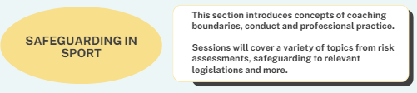

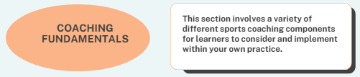

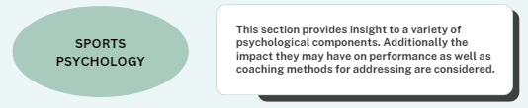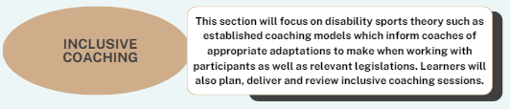

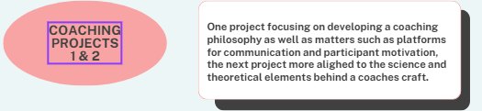

**Part 4 – What content from the originally selected units will form each of the phases?**

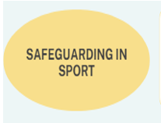

a)

|  |  |
| --- | --- |
| Unit – Developing professional practice | ALL PARTS |
| Unit – Knowing others | LO3 PART C - Understand the safeguarding & wellbeing legislation for working with vulnerable groups, including children. |
|  | LO1 PART C1 - Understand their boundaries as a coach.  You must include evidence that you understand your boundaries as a coach by covering one of the sub skills listed in the Knowledge and Skill list. For example: ♦ Safeguarding and wellbeing for different populations groups  *Evidenced could have already been gathered in the Professional Practice unit, which, providing it is relevant to the coaching context being discussed here, could be appropriate. You could provide evidence of CPD activity in relation to safeguarding and wellbeing courses, again context dependent; or you could include literary sources in relation to safeguarding and wellbeing. You must provide an explanatory narrative to confirm understanding of what the key safeguarding issues are in relation to your role as a coach if providing external activity or literary sources as evidence. |

b)

|  |  |
| --- | --- |
| Unit - TBC | TBC |
| Unit - TBC | TBC |

|  |  |
| --- | --- |
| \***Coaching Fundamentals** | Although not officially aligned to a unit – during discussions with staff involved in teaching delivery, this phase was deemed crucial for a number fo reasons which are documented below;   * ensures that practical activity is taking place from week one of program and will be a blend of tutor led demonstrations, peer coaching practice as well as free play. * Helps to consolidate theoretical knowledge being developed in class for applying to coaching scenarios * Taught in a way that encourages learners regardless of levels of experience to make mistakes and learn – all whilst building towards official coaching projects later in the term which see the learners engaging with different population groups. * *There are possibilities to collect evidence from learners in form of session plans which is likely to be considered by lecturers.* |



c)

|  |  |
| --- | --- |
| Unit – Psychology of sport & exercise | ALL PARTS |
| Unit – Knowing others | TBC - Motivational climate content could be incorporated however further discussions required based on scheduling of work – *PR more in favour at this stage of psychology related content of Knowing others being at coaching project phase.* |

d)

|  |  |
| --- | --- |
| Unit - Inclusive sport & physical activity for participants with disabilities | ALL PARTS |
| Unit – Knowing others | LO3 PART A - Understand the physical, psychological & social constraints that affects participant experience in sport.   * A) Research sport for participants with a disability:   1) Activity inclusion model (AIM)  2 STEP (space, task, equipment, people) framework  3) How to adapt & modify practice |

e/f)

e) **COACHING PROJECT 1**

|  |  |
| --- | --- |
| Unit – Knowing Yourself | All parts except LO1 PART C1 |
| Unit – Knowing Others | All parts except LO3 PART A |

f) **COACHING PROJECT 2**

|  |  |
| --- | --- |
| Unit – Knowing Coaching | ALL PARTS |

**PART 4 - Evidence grid example – which may help lecturers during resulting activity / stop and check progress meetings.**

*on the main grid section – where it shows yellow, blue, orange is an example of how lecturing staff may highlight if something has been completed – this would link to unit / & outcome the content belongs to. *Lecturers involved to decide on display that suits best.*

|  |  |  |  |  |  |  |
| --- | --- | --- | --- | --- | --- | --- |
|  | Safeguarding in sport | Coaching fundamentals | Sports psychology | Inclusive coaching | Coaching project 1 | Coaching project 2 |
| **Developing professional practice** |  |  |  |  |  |  |
| LO1 |  |  |  |  |  |  |
| LO2 |  |  |  |  |  |  |
| LO3 |  |  |  |  |  |  |
| LO4 |  |  |  |  |  |  |
| Psychology of sport & exercise |  |  |  |  |  |  |
| LO1 |  |  |  |  |  |  |
| LO2 |  |  |  |  |  |  |
| LO3 |  |  |  |  |  |  |
| Inclusive sport & physical activity |  |  |  |  |  |  |
| LO1 |  |  |  |  |  |  |
| LO2 |  |  |  |  |  |  |
| LO3 |  |  |  |  |  |  |
| Knowing others |  |  |  |  |  |  |
| LO1 |  |  |  |  |  |  |
| LO2 |  |  |  |  |  |  |
| LO3 |  |  |  |  |  |  |
| Knowing Yourself |  |  |  |  |  |  |
| LO1 |  |  |  |  |  |  |
| LO2 |  |  |  |  |  |  |
| LO3 |  |  |  |  |  |  |
| LO4 |  |  |  |  |  |  |
| Knowing coaching |  |  |  |  |  |  |
| LO1 |  |  |  |  |  |  |
| LO2 |  |  |  |  |  |  |
| LO3 |  |  |  |  |  |  |

**PART 5 - Moodle page structure for 24/25 delivery**

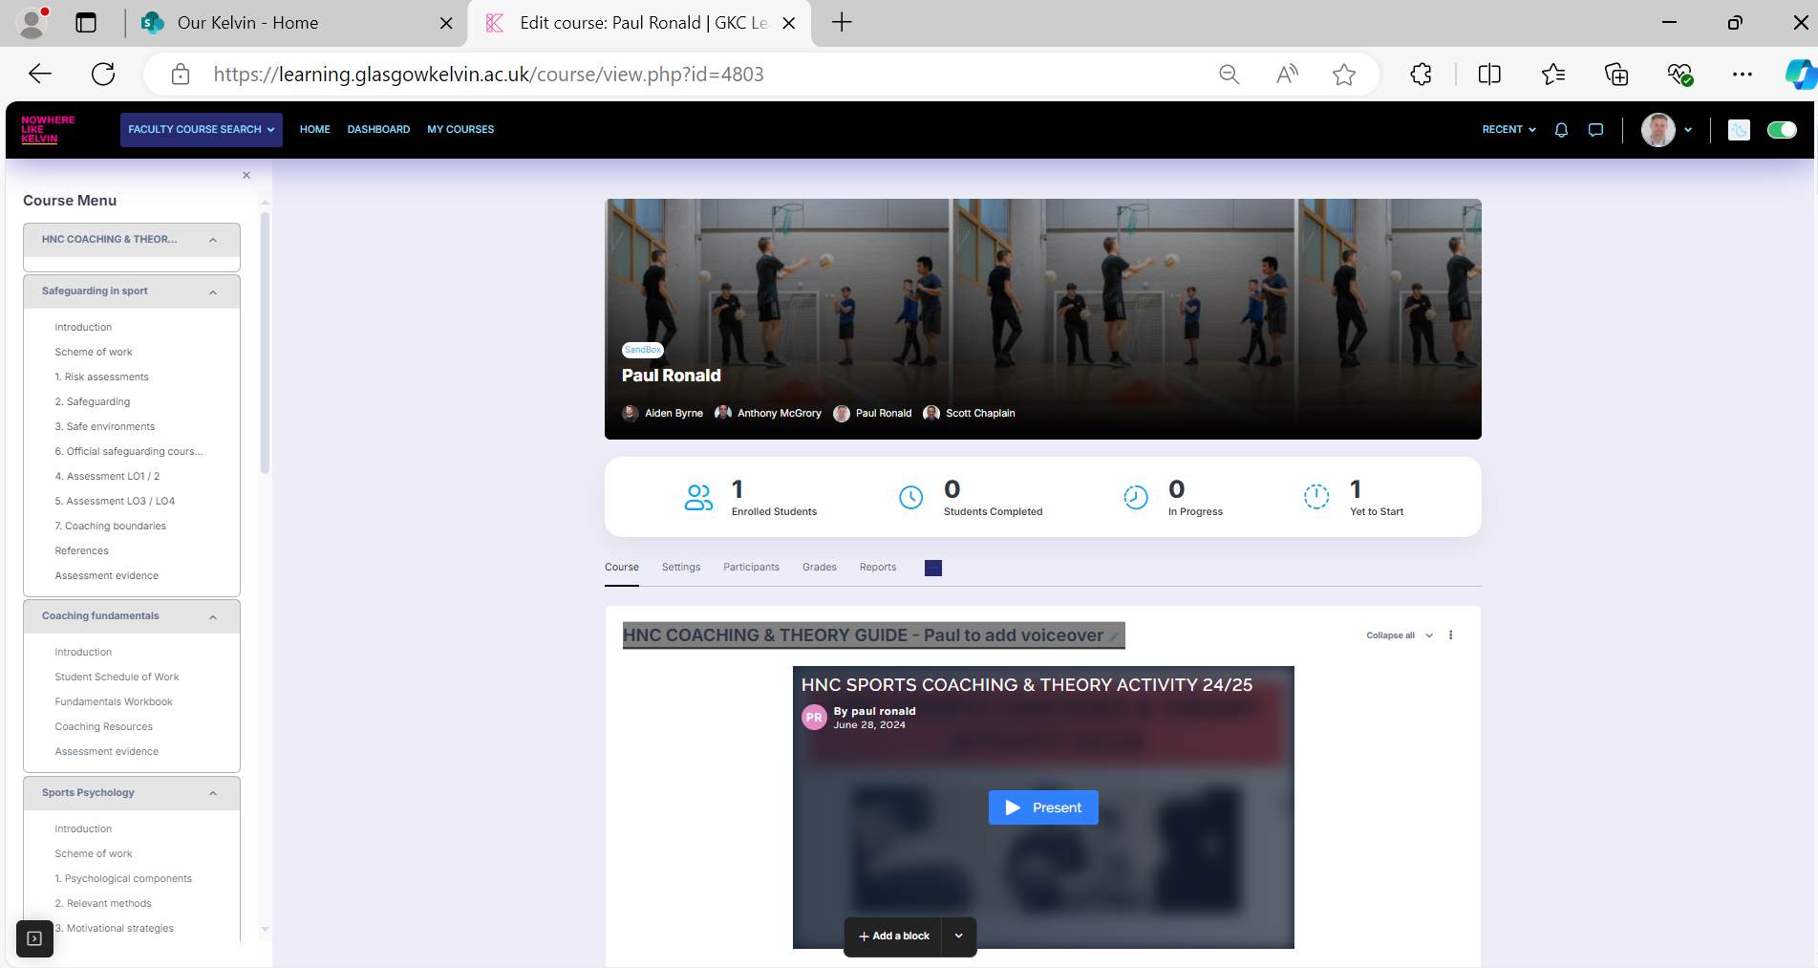

*on the left hand side will show the relevant phases previously discussed – from *safeguarding in sport* through to both *coaching projects.*

Suggested teaching approaches

* Further use of teachermatic
* Greater communication and collaboration for all lecturers involved regardless of teaching on football studies / games & sports.
* Consideration towards current employability key competencies.

***The following information highlights recent curriculum research and relevant jobs / key competencies that may be utilised and incorporated into lesson plans.***

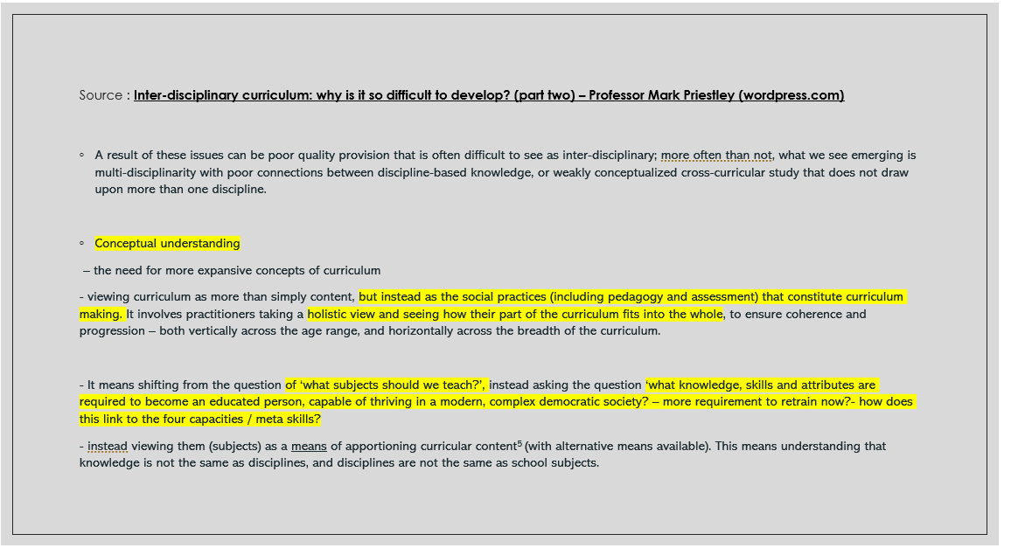*a)*

b) 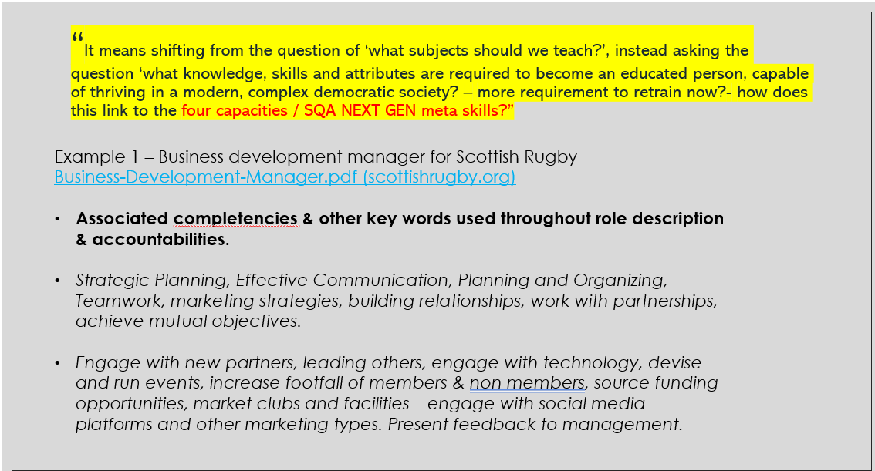

c)

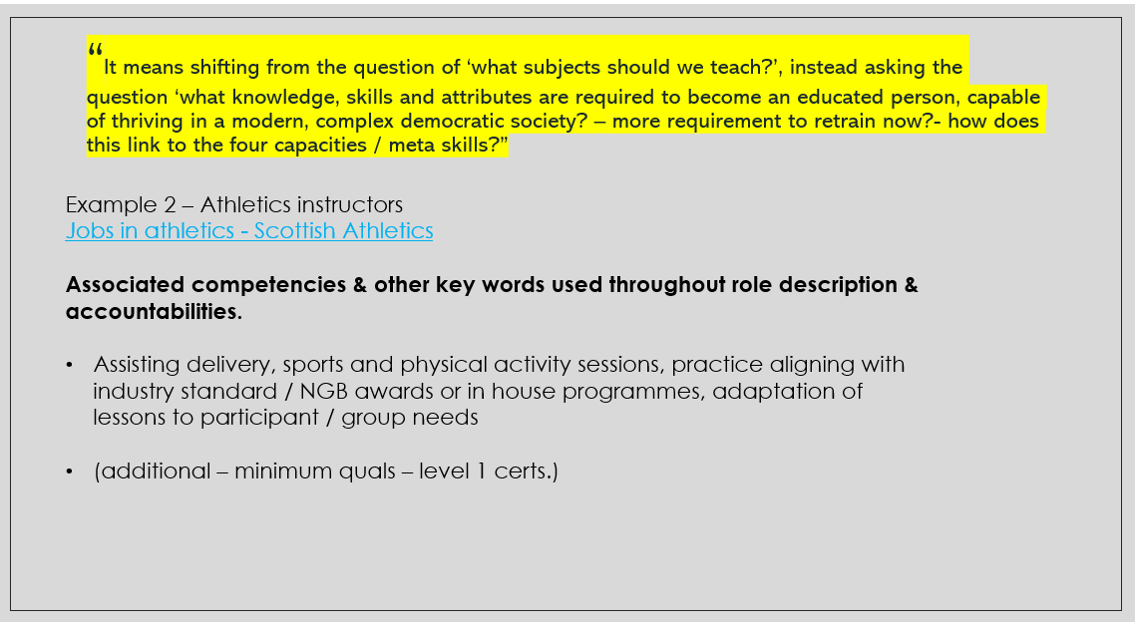

d)

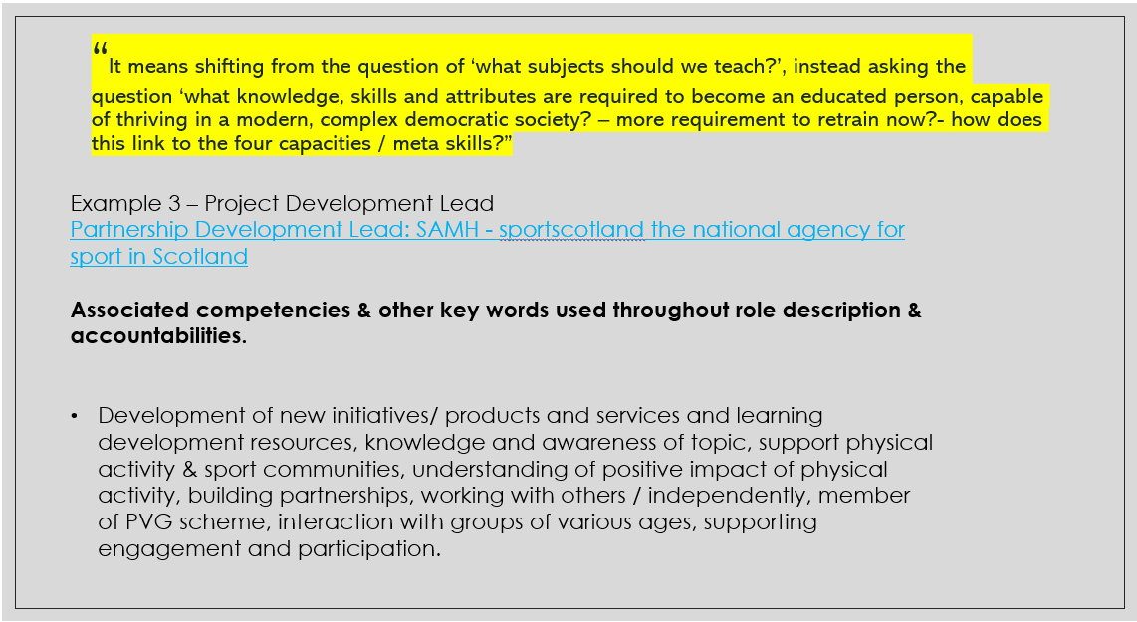

e)

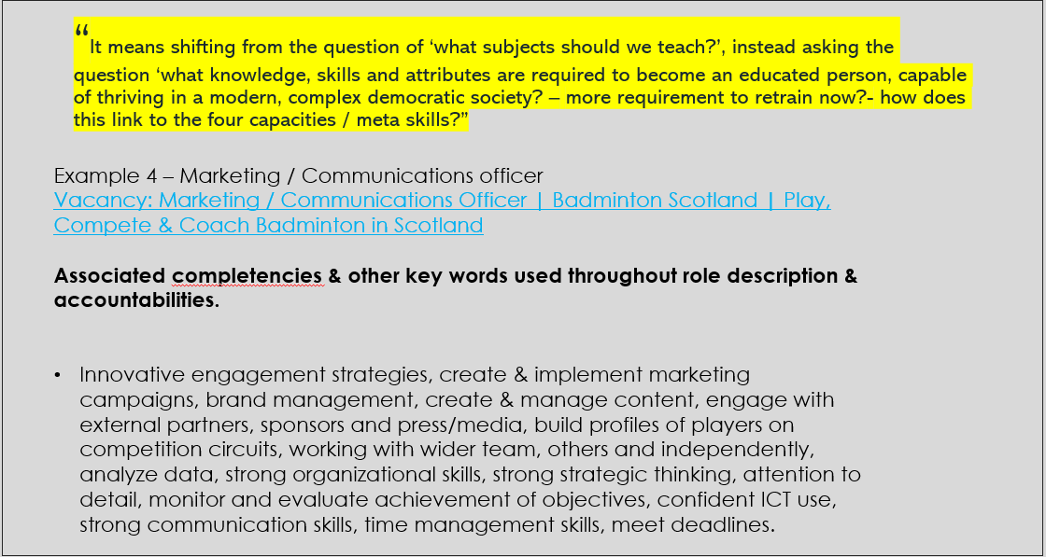

f)

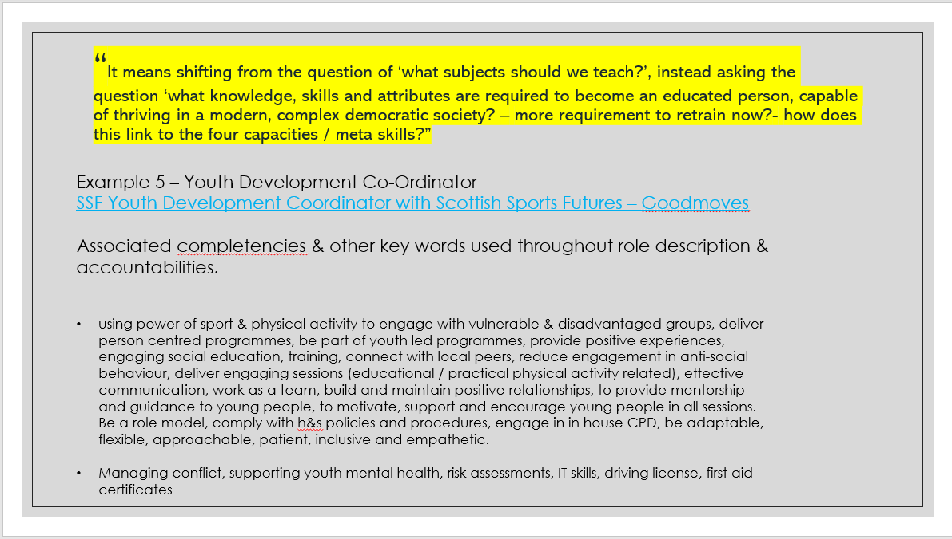

g)

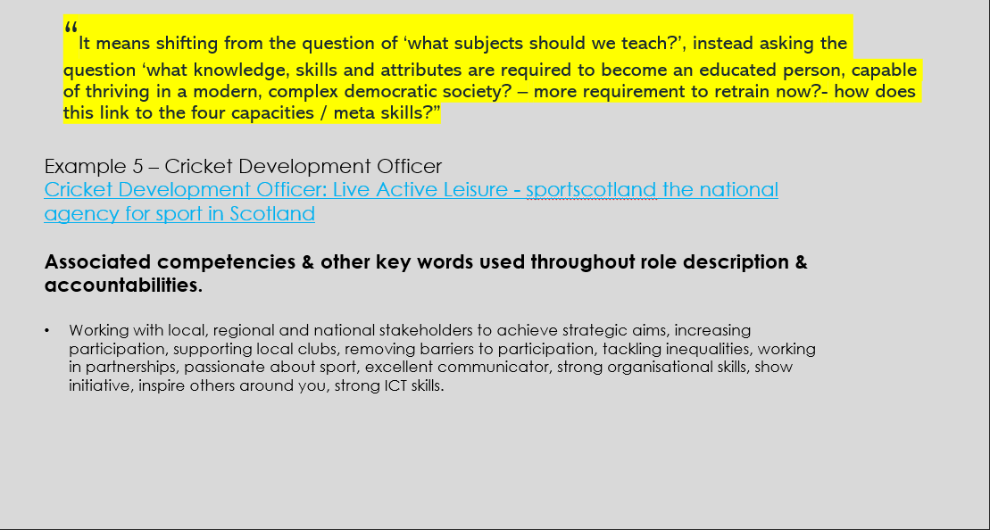

h)

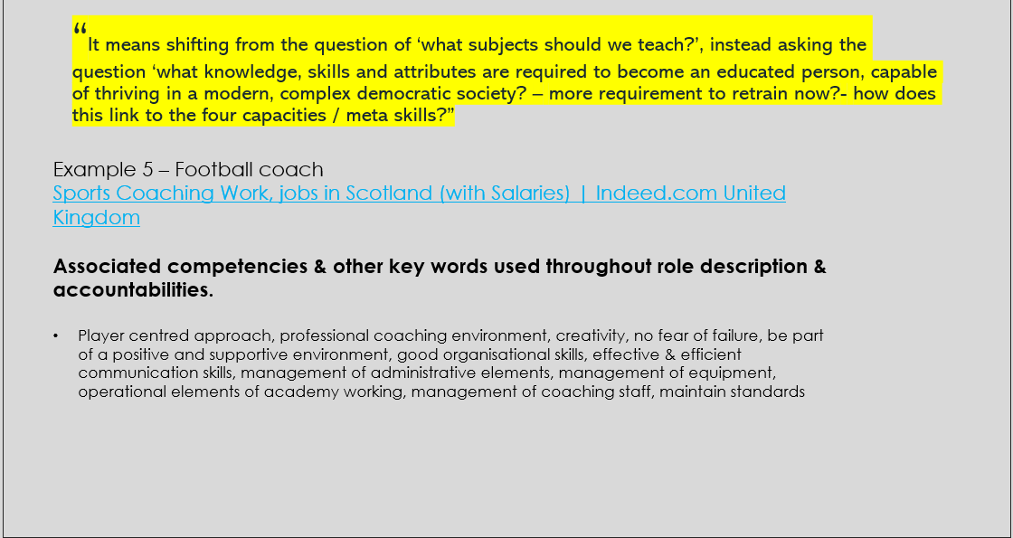

i)

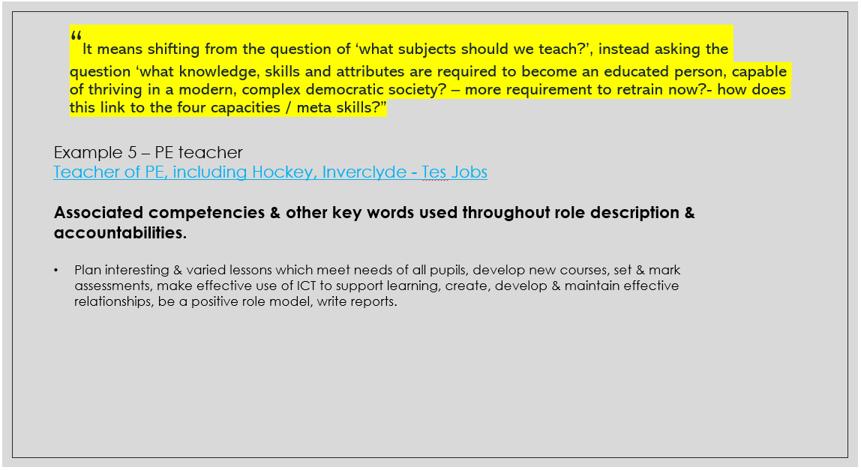

j)

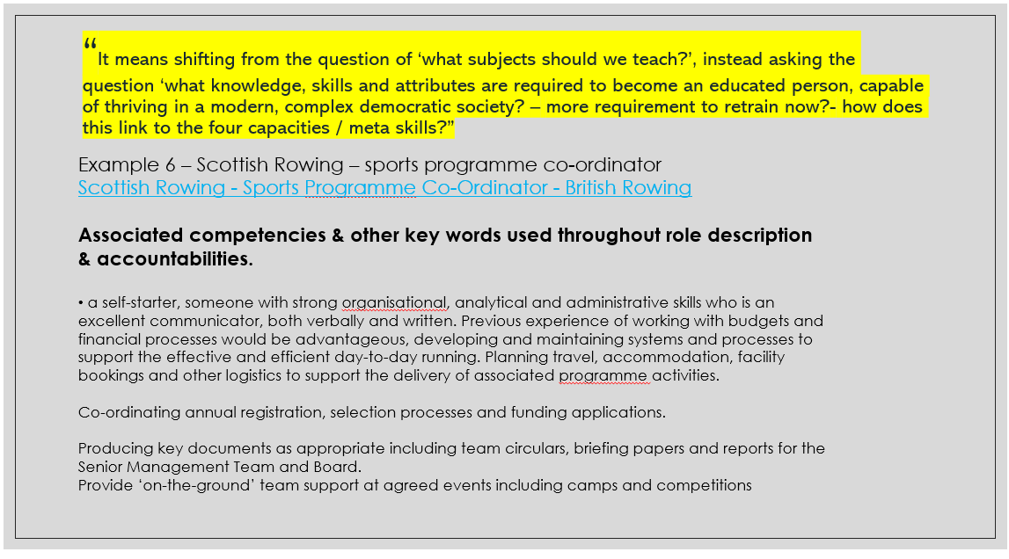

k)



l)

