**Sports Coaching and Development:**

**Developing Professional Practice**

**(J2AW 34)**

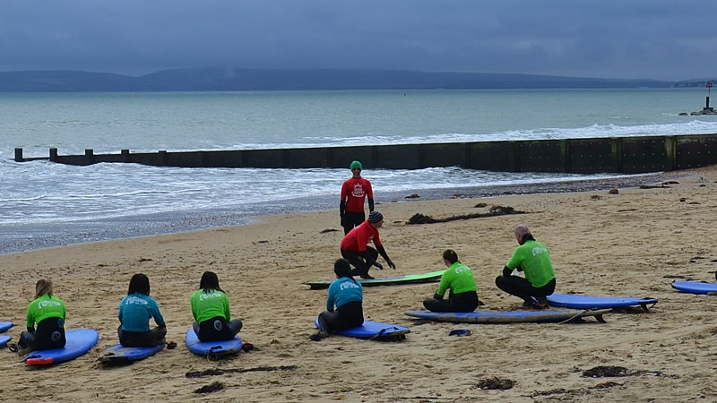

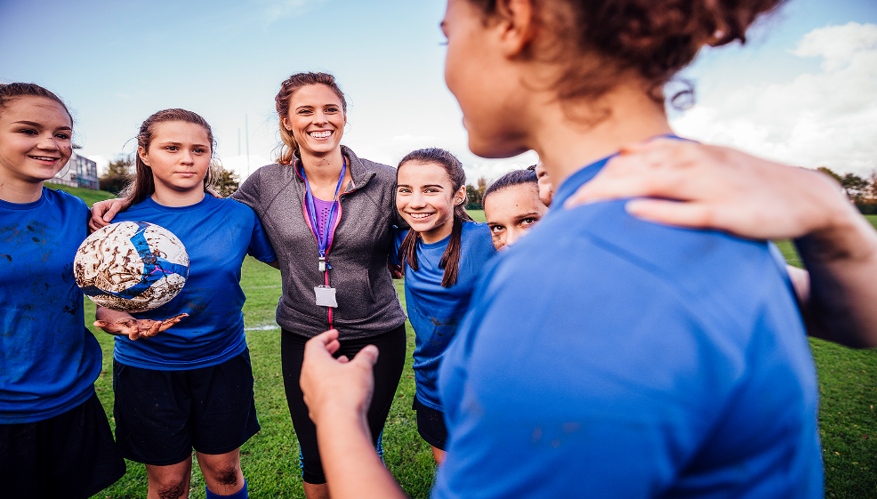

**CASE STUDIES**

**BOOKLET**

**ASSESSMENT CRITERIA**

This assessment will take the form of an open-book assessment, candidates are permitted two pages of notes on A4 paper.

This assessment will be split into two sections, each consisting of a choice between two case studies.

Candidates are required to select either case study 1A or 1B and answer relevant question paper.

Candidates are then required to select either case study 2A or 2B and answer relevant question paper.

In order to successfully complete these outcomes, candidates are required to gain 16 marks (80%) per paper.

Case Study 1A

Pascal is working as a multi-sport coach with the local council. He is coaching a hockey session in the evening to a group of teenagers aged 13-16 at the local leisure centre.

His session has been a disaster. After arriving 20 minutes late due to having to return home to pick up some equipment he forgot, he never put the group through a warm up as he had not bothered to plan one. After five minutes, a participant, Kelly, was forced to limp out of the session with what appeared to be a pulled quad muscle. Shortly after this, Sasha tripped over a kit bag which was lying close to the playing area and hurt her knee. As she fell she cut her hand on some shards of broken glass.

As part of his session Pascal delivered a conditional game. He joined in to make the teams equal but during the game he knocked over Louise, who ended up sitting out with a sore wrist.

The final incident of the session happened when Sally went over her ankle whilst shooting at goal.

Fortunately, Pascal is not required to administer first aid, as the leisure centre has a designated first aider. After seeking help the injured players were treated by the centre staff and Pascal finished the session.

At the end of the session, Pascal left before all of the participants were collected by parents and leisure centre staff failed to notice this. They were also unaware that the participants had been sharing a changing room with many adults who had been using the facility.

When Pascal arrived home he received several telephone calls from angry parents of the participants who were injured and those who had made their way home from the centre.

Case Study 1B

Emma is a trampolining coach for a local club and delivers to the under 16 development squad. Her session has been traumatic throughout. On arrival she found that some of the group had arrived early and were fooling around on equipment and had thrown water around in the changing rooms.

Emma got matters under control and began the session. Within the first ten minutes one of the participants, Naomi, performed a seat drop however her finger got stuck in the trampoline due to her wearing a large ring. Emma sent her to the changing rooms to immerse her finger in cold water and told her to sit on a bench at the side upon her return.

Later in the session another participant, Duncan, landed awkwardly during a basic routine. Emma instructed him to sit at the side to recover, he later re-joined the activity.

At the end of the session, when dismantling the trampoline, a leg brace struck Emma in the face and cutting her above her eye. She remembered that she had not checked the leg brace for some time despite it regularly being difficult to slot into place when setting up and dismantling the trampoline. In an irate state Emma summoned a participant to go to reception to get a first aider to see to her and Naomi. She then turned to notice Simon and James swinging on a football goal which collapsed causing James to sustain a nasty looking wrist injury.

A first aider arrived and administered first aid to Naomi, James and Emma all of whom required to go to hospital for treatment. Emma took them all to hospital in her car after completing accident report forms. Following treatment Emma dropped off Naomi in town to take a short walk home then dropped James off at his house.

At the next practice session, James’ parents appeared making threats to go to the police accusing Emma of sexual innuendo and abuse.

Case Study 2A

The local swimming club for young people with disabilities has hastily recruited a temporary coach, Sam Douglas. He replaces the usual coach Mary who is recuperating from a recent hip operation. Sam is new to the area, having moved from abroad, but has a wealth of experience and several coaching qualifications. Apart from that, little is known about him. He is preparing the squad for a prestigious event, which scouts for the Paralympics will be attending. Being new to the club Sam arranges for assistant coaches who are well known to the participants to accompany the squad to the event.

One of the athletes – Steve is a strong swimmer who has trained hard to overcome injuries sustained in a car accident. On the day of the event, Sam discovers that Mary has failed to keep accurate data for the team, and, according to the rules, Steve should be swimming in a different classification than the one he has been entered in. Another athlete has withdrawn due to illness. Feeling stressed Sam goes to his hotel room and has several alcoholic drinks to calm him down.

Feeling more relaxed, Sam returns to the pool and attempts to find a replacement for the withdrawn athlete. The first person he comes across is Nadeem, an Asian boy, who he is wary of selecting for the additional race as he is aware that parents of the other children will be displeased at Nadeem being given an extra opportunity to perform in front of the scouts. In an attempt to retain his popularity with parents, Sam decides against giving Nadeem the opportunity. Sam then approaches Michael who is suffering from an eye infection and on medical grounds has been told to limit his time in the water to prevent the condition from worsening. Sam tells Michael to put in eye drops and wear goggles and he will be fine to take the extra race.

Sam the seeks out Andy, the reserve swimmer in the squad, to replace Steve. Andy is delighted and begins to prepare for his race, however, Steve reacts badly to the news he is being withdrawn and has a heated discussion with Sam. Following the discussion Sam gives in and tells Steve he can still compete but will have to lie about his disabilities, if asked, so he can compete in the classification he was entered for. Andy is then told he is no longer needed and is back to being the reserve.

Later that evening when doing a routine check on athletes at the hotel, Susan the assistant coach, hears sobbing from one of the rooms. She knocks before entering the room to find one of the female athletes, Dawn, extremely distressed. Following some patient questioning Dawn tells Susan that Sam had been to her room and asked her to add him on social media and send him some pictures. Susan is shocked by this and doesn’t know what to do as Sam is the acting head coach. She decides to wait until the event is finished at the end of the week and worry about it when she gets home.

Following the event several parents get in touch with the club chairperson to raise concerns about the various incidents that occurred.

**Case Study 2B**

Lewis, an experienced gymnastics coach has decided to set up his own club with a couple of former colleagues rather than continue to work for the local council. They find a large hall connected to a private fitness club. His former colleagues have agreed to be chairperson and secretary for the club whilst allowing Lewis to focus on the coaching. Lewis works with the chairperson and secretary to write up policies and procedures, but Lewis reckons by running his own club he will not be forced to adhere to rules and regulations like when he worked for the council. He also feels like he will have scope to earn more money by having more gymnasts at each session.

Lewis has a couple basic gymnastic qualifications; however, he advertises his sessions to give off the impression he has excellent credentials. He has avoided doing NGB coach educator courses as he feels they aren’t good value for money.

In the first week of his new venture he arrives late for a session. The 23 participants have started setting out equipment and doing a warm up. Rather than focus on delivering his session he spends several minutes gloating to parents about the number of children he has attracted to his session. He has considered recruiting assistant coaches but is enjoying pocketing the additional money. Due to the vast numbers he has let his admin slip and hasn’t been completing registers for the sessions.

Towards the end of the session one of the personal trainers from the fitness club pops in to have a chat with Lewis. Lewis informs the personal trainer he has agreed to deliver one to one sessions to a talented gymnast, Anna, after the planned session finished. He tells the personal trainer that he will lock up the main door after he finishes.

An hour later, the personal trainer returns to the facility because he has forgotten his house keys. As he passes the door he hears Lewis unleash a tirade of abuse to Anna because she made a mistake. Lewis Rants at the top of his voice and during his rant he makes a sexist remark. The personal trainer enters and challenges Lewis about his conduct. Lewis barks at the personal trainer and tells him to mind his own business. The personal trainer leaves the venue having been intimidated by the response from Lewis. He makes an accurate record of what he observed and he immediately contacts the chairperson of the club to report his concerns.