Higher Chemistry in Society Tutorial

**Key area: Getting the most from reactants**

1. Butane, C4H10 can be converted into methane, CH4 and propene, C3H6.

C4H10 🡪 CH4 + C3H6

1. Calculate the theoretical yield, in tonnes, of propene, that can be produced from 150 tonnes of butane.  
     
   FM C4H10 = 58g  
   FM C3H6 = 42g  
     
   n = mass/FM = 150/58 = 2.59 moles  
   1:1 ratio  
   mass = n x FM = 2.59 x 42 = 108.6 tonnes

1. The actual yield from 150 tonnes of butane is 86.3 tonnes of propene. Calculate the percentage yield of propene.   
     
   (86/108.6) x 100 = 79.2%
2. Why is the % yield rarely 100% for a process?  
     
   Mass transfer loss, experiment not reaching completion, back reaction taking place.
3. What is the atom economy for the production of propene?  
     
   (42/58) x 100 = 72.4%
4. Why is the atom economy rarely 100% for any process?  
     
   side products
5. Propane, C3H8 reacts with oxygen in a combustion reaction to form carbon dioxide and water:  
     
   C3H8(g) + 5O2(g) 🡪 3CO2(g) + 4H2O(l)
6. If 100cm3 of C3H8 was reacted with 600cm3 of oxygen, what is the remaining volume of gas left unreacted?  
     
   100cm3 of oxygen
7. Which is the limiting reagent?  
     
   propane
8. Which is in excess?

Oxygen

**Key area: Equilibria**

1. Sulphur dioxide is reacted with oxygen to produce sulphur trioxide.

2SO2(g) + O2(g)  2SO3(g) ΔH = -395.7 kJ mol-1

1. State the effect of increasing the pressure on the equilibrium position.  
     
   forward reaction favoured
2. A platinum catalyst is added to the reaction vessel. State the effect of using a catalyst on the equilibrium position.  
     
   none
3. State the effect of increasing the temperature on the position of the equilibrium.  
     
   reverse reaction favoured
4. Give two measures for increasing the yield of sulphur trioxide  
     
   increase reactant concentration  
   remove sulphur trioxide that is produced  
   use low temperature  
   use high pressure

**Key area: Chemical energy**

1. Using bond enthalpy values, calculate the enthalpy change for the

following addition reaction.

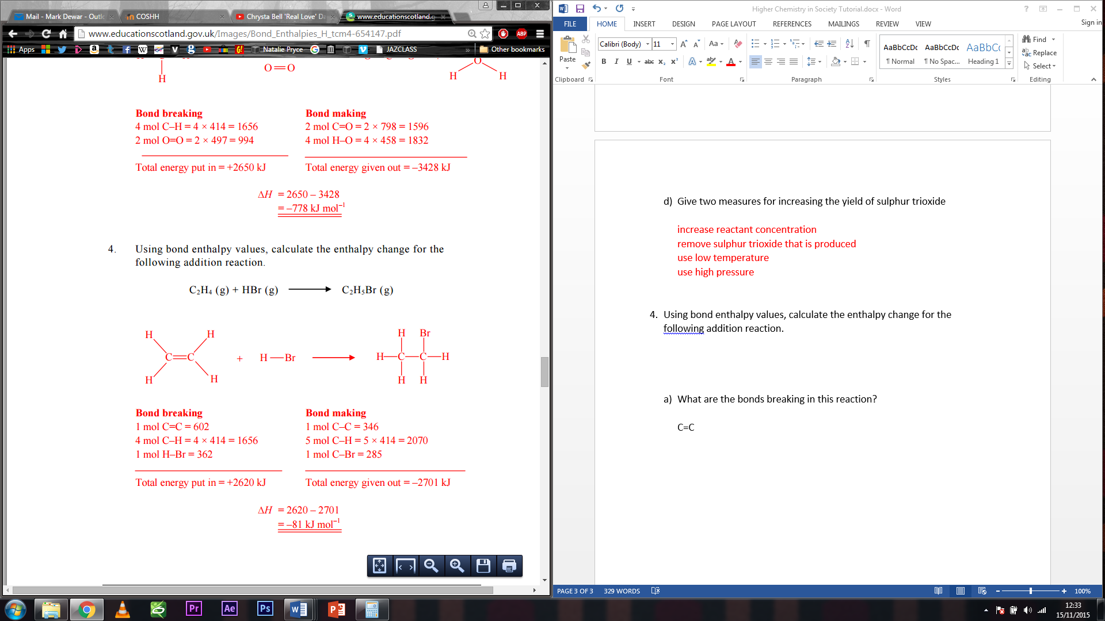

1. What are the bonds breaking in this reaction?  
     
   C=C = 602  
   H-Br = 362  
     
   Total = 964kJ
2. What are the bonds being made in this reaction?

C-C = 346

C-H = 414  
C-Br = 285  
  
Total = -1045kJ

1. What is the enthalpy change for the reaction?

964 + -1045 = -81 kJmol-1

1. Consider the enthalpy changes in the diagram shown below.

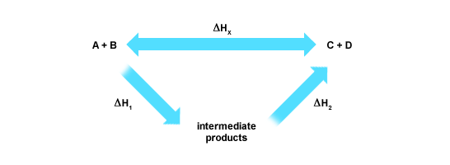

If, ΔHx = -219 kJ mol-1  
ΔH1 = -90 kJ mol-1

What is the value for ΔH2?  
  
-219 - -90 = -129 kJ mol-1

1. Methane gas, CH4 can be used as a fuel source when combusted with oxygen.  
     
   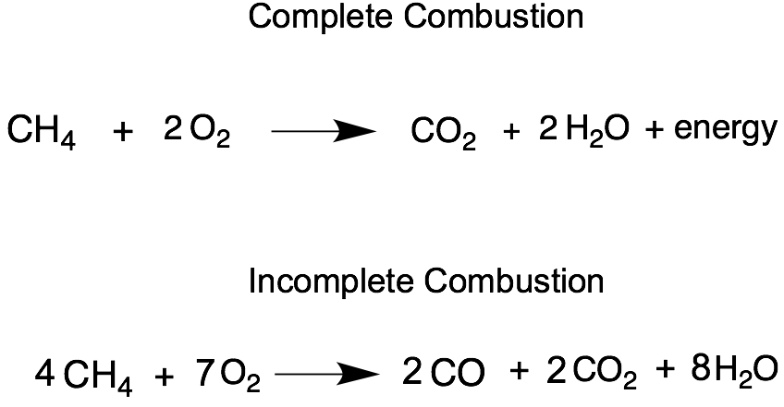  
     
   An experiment was carried out where 0.25 mols of methane was burned to release 208.5 kJ of energy. Calculate the experimental value for the combustion of methane.  
     
   1/0.25 = 4  
     
   4 x 208.5 = 834 kJ mol-1

**Key area: Oxidising or reducing agents**

1. For the following oxidation and reduction reactions:  
     
   oxidation: Cr(OH)3  http://www.chemistry.wustl.edu/~coursedev/Online%20tutorials/arrow.gif CrO42 + 3e-  
   reduction: Br2 + 2e- http://www.chemistry.wustl.edu/~coursedev/Online%20tutorials/arrow.gif  2Br-
2. Combine these two equations to give the overall redox equation.

2Cr(OH)3  http://www.chemistry.wustl.edu/~coursedev/Online%20tutorials/arrow.gif 2CrO42 + 6e-  
3Br2 + 6e- http://www.chemistry.wustl.edu/~coursedev/Online%20tutorials/arrow.gif  6Br- 

Cancel electrons and add up  
  
2Cr(OH)3  + 3Br2 http://www.chemistry.wustl.edu/~coursedev/Online%20tutorials/arrow.gif2CrO42 + 6Br-   
  
add water   
  
2H2O + 2Cr(OH)3  + 3Br2 http://www.chemistry.wustl.edu/~coursedev/Online%20tutorials/arrow.gif2CrO42 + 6Br-   
balance with H+  
  
2H2O + 2Cr(OH)3  + 3Br2 http://www.chemistry.wustl.edu/~coursedev/Online%20tutorials/arrow.gif2CrO42 + 6Br- + 10H+

1. Which reactant is acting as the oxidising agent?   
   Br2
2. Give a reason for your answer to part (b).  
     
   It is itself reduced, it accepts electrons.
3. What is the commercial use for oxidising agents?

Kills fungi/bacteria /inactivate viruses/bleach/disinfectant/or any other appropriate response

**Key area: Chemical analysis**

1. A 20cm3 solution of sulphuric acid solution was titrated with a standardised solution of accurately known concentration (0.0500 mol/dm3) of potassium hydroxide.

Using phenolphthalein indicator for the titration, the acid required 36.0 cm3 of the alkali KOH for neutralisation.

**2KOH(aq) + H2SO4(aq)**http://www.chemistry.wustl.edu/~coursedev/Online%20tutorials/arrow.gif **K2SO4 + 2H2O(l)**

1. Calculate the number of moles of sulphuric acid reacted in the titration.

n = c x v = 0.05 x 0.036 = 0.0018 moles of KOH  
  
2:1 ratio  
  
0.0009 moles of acid

1. Calculate the mass of potassium hydroxide used in the titration.  
     
   mass = n x FM = 0.0018 x 56 = 0.1g