ANSWERS:

1. D
2. D
3. Bonds broken: +432, +243 = 675 kJ  
   Bonds formed: 2 x (-428) = -856 kJ  
   ΔH = -181 kJ
4. (-92.3 + -134.5) – (-74.8) = -152 kJmol-1
5. ΔH = [+335 + (-17) + (-242)] = 76 kJmol-1
6. NO2 − (aq) + H2O(l) 🡪 NO3 − (aq) + 2H+ (aq) + 2e−
7. 0·0324 mol l−1
8. 24.8%
9. 2mol NH3 gives 1mol (NH2)2CO  
   34g gives 60g  
   300 tonnes
10. An excess of ammonia will push the equilibrium to the left.
11. There are more moles of gas on the right-hand side of the equation. The forward reaction will be favoured by low pressure causing the carbamate to break down.
12. RDA (60kg adult) = 900 mg   
    Mass of tuna = 119g
13. Tyrosine
14. Circle draw as:  
    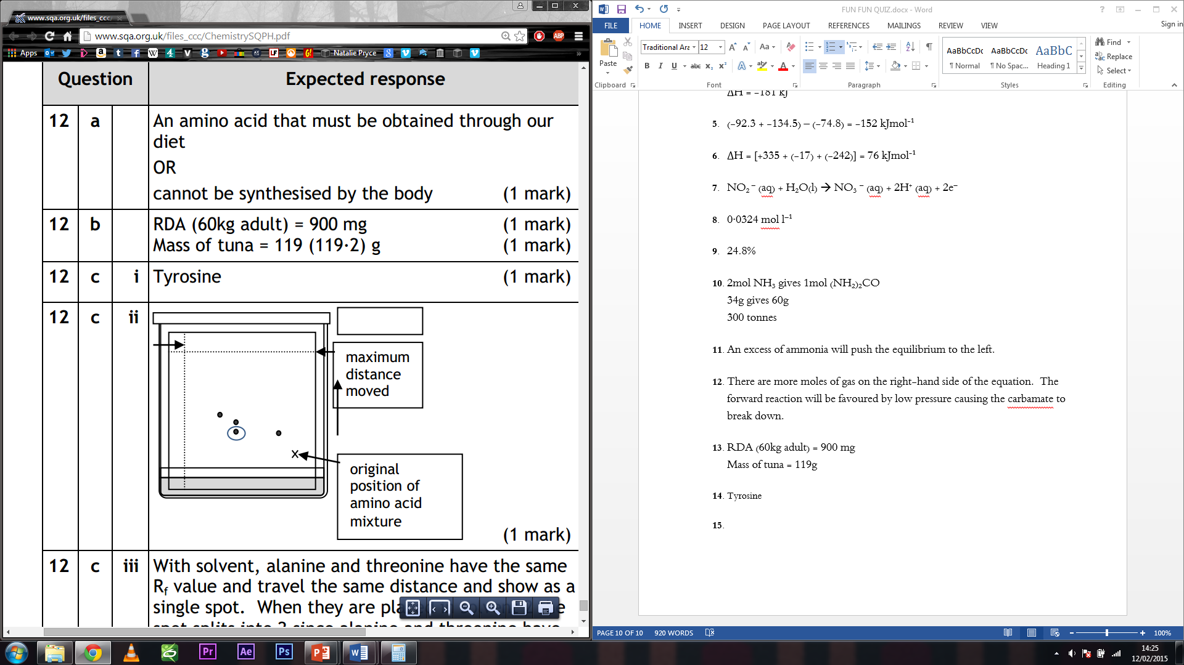
15. With solvent, alanine and threonine have the same Rf value and travel the same distance and show as a single spot. When they are placed in solvent 2 the spot splits into 2 since alanine and threonine have different Rf values.
16. 16H+ + 10 e- + 2 MnO4- http://www.chemistry.wustl.edu/~coursedev/Online%20tutorials/arrow.gif 2Mn2+ + 8H2O  
    10H2O + 5SO2 http://www.chemistry.wustl.edu/~coursedev/Online%20tutorials/arrow.gif 5HSO4- + 10e- + 15H+
17. D
18. B
19. + 129 kJ mol-1