Equilibrium and Le Chatelier’s Principle

Aim:

To investigate the effect of changing conditions on several aqueous equilibria.

Introduction:

Le Chatelier's principle states that when a system in equilibrium is disturbed by a change in temperature, pressure or concentration, the system shifts in equilibrium composition in a way that tends to counteract this change. This principle can be demonstrated by investigating the effect of changing conditions on some simple equilibria in aqueous solutions.

Procedure 1:

In an aqueous solution of iodine, the following equilibrium is established:  
  
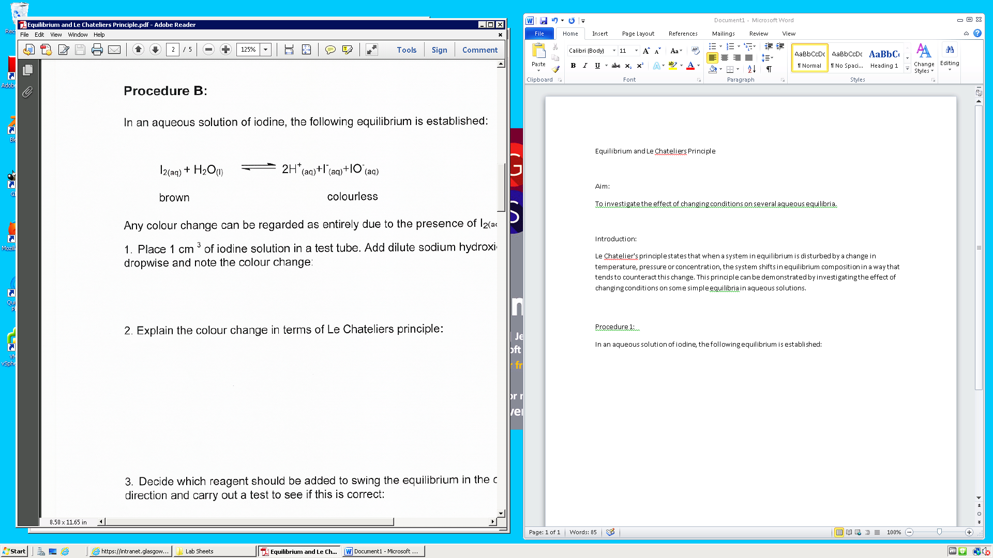

Any colour change can be regarded as entirely due to the presence of I2(aq).

1. Place 1 cm3 of iodine solution in a test tube. Add dilute sodium hydroxide solution 2mol/l dropwise and note the colour change:
2. Explain the colour change in terms of Le Chateliers principle:
3. Decide what reagent could be added to swing the equilibrium in the opposite direction and carry out a test to see if this is correct:

Procedure 2:

Cobalt (II) salts readily form complex compounds. The pink aqueous solution of cobalt (II) salts are characteristic of the complex ion [Co(H20)6]2+,in which the cobalt (II) ion is bonded to six water molecules in an octahedral arrangement.

If Cr- ions are present in sufficient concentrations, they will compete with the water molecules for bonding to the cobalt ion to form a deep blue solution of CoCI42- ion. The resulting equilibrium may be written as follows:  
  
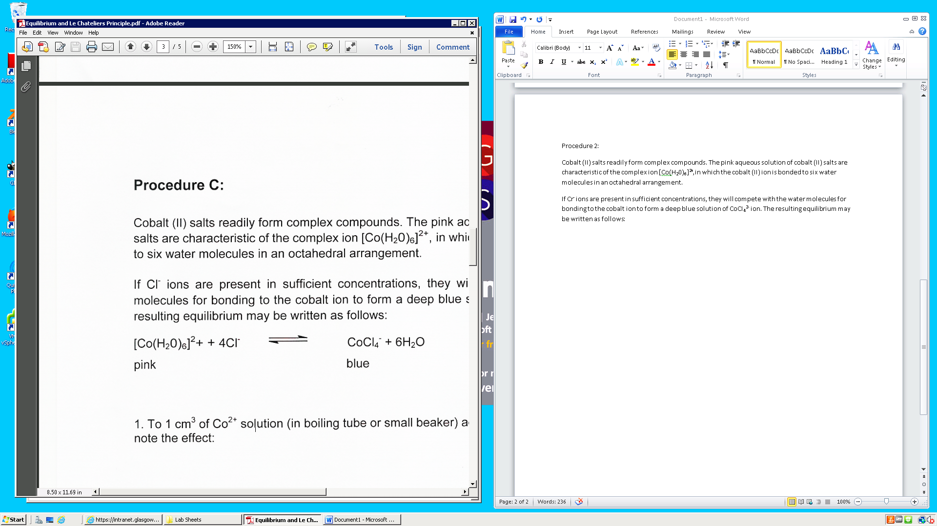

1. To 1cm3 of Co2+ solution (in boiling tube or small beaker) add 2cm3 of 10mol/l concentrated HCI and note the effect:
2. Add 5 cm3 portions of distilled water to the test tube and note the effect:
3. Explain the changes in terms of Le Chatelier’s principle:

Procedure 3:

1. In a small conical flask mix 10cm3 of Co2+ solution and 8cm3 of concentrated hydrochloric acid to produce a violet solution (halfway between the original pink and bright blue). If necessary, adjust the colour by adding concentrated hydrochloric acid or distilled water a drop at a time.
2. Divide the solution into three test tubes; keep one at room temperature, place one in an ice bath and the other in a beaker of boiling water.
3. Observe the colour changes and determine how temperature affects the balance of equilibrium:
4. Determine whether the reaction as written is exothermic or endothermic:
5. Explain the changes in terms of Le Chatelier’s principle: