Introduction

Vitamin C (ascorbic acid) is an important component of our diet. In its absence the protein, collagen, cannot form fibres properly and this results in skin lesions and blood vessel fragility.

Although vitamin C occurs naturally in many fruits and vegetables, many people take vitamin C tablets o supplement their intake.

Vitamin C can undergo a redox reaction with iodine in which the vitamin C is oxidised and the iodine molecules are reduced.

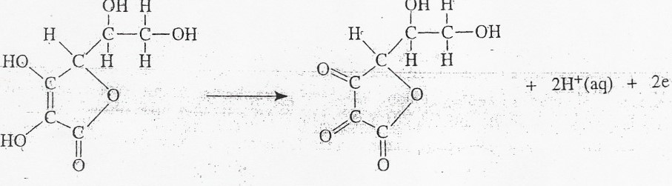

OH

H

12(aq) + 2e 21-(aq).

AIM

The aim of this experiment is to determine the mass of vitamin C in a tablet by carrying out a redox titration -using -a solution of- -iodine of accurately known concentration and starch solution as an indicator. 

Requirements

|  |  |
| --- | --- |
| small beaker | Standard solution of iodine 0.025M |
| wash bottle | Starch solution 1% |
| 250cm3 standard flask | Vitamin C tablet |
| Filter funnel 25cm3 pipette 50cm3 burette conical flask pipette filler white tile | Deionised water |

Hazard

The iodine solution irritates the eyes.

Care 

Wear eye protection and wash your hands if any iodine solution spills on them.

Procedure

1. Add half a vitamin C tablet to the beaker.
2. Add some deionised water (approximately 50 cm3) to the beaker and stir the mixture until the tablet has dissolved.
3. Carefully add the resulting solution to the 250cm3 standard flask. Rinse out the beaker several times with water and add the washings to the flask.
4. Add water to the standard flask to bring the volume of the solution up to the graduation mark.

5. Stopper the flask and invert it several times to make sure the solution is thoroughly mixed.

6. After rinsing the pipette with a little of the vitamin C solution, pipette 25 cm3 of it into the conical flask.

1. Add a few drops of starch solution to the vitamin C solution in the conical flask.
2. After rinsing the burette with a little iodine solution, fill the burette with the iodine solution.
3. Note the initial burette reading. Since the solution has a dark colour, it is difficult to see the bottom of the meniscus. Take the burette reading from the top of the meniscus.
4. Add the iodine solution slowly from the burette whilst gently swirling the solution in the conical flask. Initially you will see a blue/black colour as the iodine reacts with the starch but this will rapidly disappear, as the-iodine reacts with the vitamin C.

11 . Near the end-point of the titration, the colour disappears more slowly. At this point, add the iodine solution drop by drop until the solution just turns a blue/black colour and remains so.

1. This is the end-point of the titration i.e. all the vitamin C has reacted. Note the final burette reading.
2. Wash out the conical flask.
3. Repeat the titrations until concordant results are obtained.

# Calculation

Suppose the average titre volume was 22.1 cm 3 and the iodine solution had a concentration of 0250 mol/l

*from the average titre volume in litres (V) and the concentration of the iodine solution (C), we can calculate the number of moles of iodine (n) used in the titration:*

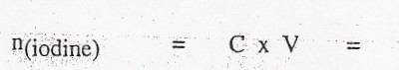0.0250 x 0.0221

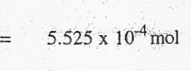

We can now use the balanced redox equation to calculate the number of moles of vitamin C in a 25cm3 sample of the vitamin C solution:

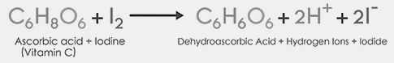

* + - 1. mol 🡪 1 mol

5.525 x 10-4 mol 🡪 5.525 x 10-4 mol

But there were 250cm3 of vitamin C in total and so to determine the number of moles of vitamin C in the tablet we have to scale up our last answer:

n (vitamin C) per tablet = l0 x 5.525 x 10-4

5.525 x 10-3 mol

Vitamin C: C6H806

Mass of 1 mole = 6(12) + 8(1) + 6(16) = 176g

We can now calculate the mass of vitamin C per tablet:

Mass of vitamin C per tablet = 176 x 5.525 x 10 3 **= 0.972g**



1. Knowing the average volume and concentration of the iodine solution used in the redox titration, the number of moles of iodine can be calculated.
2. With the result from step (a) and the balanced equation for the redox reaction, we can work out the number of moles of vitamin C in 25 cm3 of the vitamin C solution. This can then be scaled up to find the number of moles of vitamin C in 250 cm3 of the vitamin C solution.
3. Your final answer in step (b) will, of course, be equal to the number of moles of vitamin C in the tablet. Using this result and the mass of one mole of vitamin C (176 g) we can finally work out the mass of vitamin C in the tablet.

|  |  |  |  |  |  |
| --- | --- | --- | --- | --- | --- |
|  | **First titration (rough)** | **Second Titration** | **Third Titration** | **Fourth**  **Titration** | **Fifth**  **Titration** |
| **Initial Burette reading (ml)** |  |  |  |  |  |
| **Final Burette reading (ml)** |  |  |  |  |  |
| **Volume of NaOH taken (ml)** |  |  |  |  |  |