**Graded Unit 2**

***12 Week Athletic Training Programme with Male Client***

**Contents**

**Introduction………………………………………………………………………………….3**

**Aims and Objectives……………………………………………………………………...3**

**The Client……………………………………………………………………………………...3**

**Fitness Testing………………………………………………………………………………4**

**Research……………………………………………………………………………………….5**

**Action Plan……………………………………………………………………………………5**

**Nutrition……………………………………………………………………………………….6**

**Exercise Programme……………………………………………………………………...7**

**Problem Solving…………………………………………………………………………….8**

**Conclusion…………………………………………………………………………………….9**

**Bibliography………………………………………………………………………………….9**

**Appendix………………………………………………………………………………………10**

**Introduction**

The aim of this project is to improve athleticism and strength using training methods to improve explosiveness and strength specific to an elite athlete’s sport. This project was carried out over 12 weeks with a 20 year old male client who is relatively experienced in the gym. He has been attending the gym for around 4 years consistently with a structured approach to training, however, the programming was not fully suitable to basketball, which is the sport he competes in. By using fitness testing and interviewing the client, the programme was created specific to the clients aims and needs with a few changes in the latter stages due to the COVID-19 pandemic and lockdown restrictions.

**Aims and Objectives**

The aim of the project was to increase strength, power, and athleticism over 12 weeks of training. Using strength and power resistance training as well as acceleration and max velocity sprint training with one session of cardio-vascular training per week to keep on top of the client’s CV ability, all to aid in preparing for the basketball season.

Objectives

Carry out 2 sport specific strength sessions per week using 5-3-1 wave loading periodisation

Complete a power session each week with Olympic Lifts to aid in athletic improvement

Implement correct sprinting technique to aid with power production improvements

1 Cardio-Vascular session each week to help maintain general fitness

**The Client**

The client that carried out the training programme is a 20 year old male with gym and programming experience. He has a very active lifestyle being a student as well as an athlete, playing basketball competitively, which takes a lot of energy as well as putting strain on his skeletal muscular system. Playing basketball, there is a lot of strain on the client’s tendons and ligaments, especially in the ankles, knees, and hips, with it being such an explosive sport, so rest is a huge part of his life to stay in good condition.

From the Par-Q, the client discloses that he has no issues medically and had no injuries in the past 12 months so the programme can go ahead without much risk of aggravating anything. He stated that he is allergic to baby food, however, this should not be an issue as it is not something that is needed for someone of his age. He is not allergic to any medication or supplements and he is not taking any medication that could have any kind of affect do his progress.

He stated in the Par-Q that he has taken part in some sort of programmed exercise for around 2-3 years, training almost every day. As a trainer, there is no worry of lack of motivation or slacking off as he is obviously a serious, determined athlete who cares about improvements.

Consent was given before the beginning of this programme (appendix) which made sure the client gave me permission to keep their sensitive data safe and to be able to share any results the project requires.

***Client’s Goals***

The aim of my client as stated in an interview and in the Par-Q was to improve strength and athleticism over the 12 week period which is exactly the aim of this project. The client wanted to be prepared for the basketball season, being stronger and more athletic than the season before, however, due to the COVID-19 pandemic, there was no word of when or if the season will start so he wanted to be prepared, nonetheless. Using 5-3-1 wave loading periodisation with three 4-week blocks, the clients 1 rep max was calculated from the number of reps the client completed at 95% of their previously perceived 1RM and this was used to track the clients progress over the 12 weeks.

***Dietary habits***

The client eats a healthy diet, eating 4 meals a day with vegetables, protein, carbohydrates, fats and dairy while eating fruit and nuts as snacks. He does not drink alcohol or eat out often and he drinks around 3 litres of water a day.

***Lifestyle Habits***

The chosen client is very active, training for at least 1 hour a day, 6 times per week. Other than his training, he does not do much else other than his work for college and helping around the house as he said in bis interview prior to the starting of this project. He aims to get over 8 hours of sleep each night which is perfect for an athlete as it is recommended for an average adult to get between 7 and 9 hours of sleep each night but Walsh, Halson et al (2020) suggest that an athlete should have even more to be able to recover appropriately.

**Fitness Testing**

Fitness Testing is an example of primary quantitative data, which means that it is first-hand data using statistics and numbers. I used two different kinds of fitness testing, the first is static fitness testing which involves measuring height, weight, body composition, resting heart rate and blood pressure of the client. The second is dynamic testing which tests the client’s muscular endurance, cardiovascular ability, flexibility, and their strength. These two methods were useful in gaining a good picture of the client’s capabilities and highlighted anything that could be issues before starting the programme.

From the dynamic fitness testing, I could see that there were improvements in the client’s strength and power throughout the programme with him hitting personal bests in many of his lifts, especially with his squats and Olympic lifting. This will correlate to any improvements athletically as according to Valle (2021), squatting improvement does lead to an increased performance in power and speed, especially if the athletes squat is higher due to a jump not needing a full range of motion to get the maximum explosion through your legs. There was also improvement in other key lifts such as the bench press, deadlift and pull ups (see Appendix for results).

Some key points from the fitness testing are that the client had a BMI of someone in good health so that put the client in a good place physically to start the programme. This was maintained throughout the programme by the client also keeping on top of his nutrition as well as exercise regime.

**Research & Resources**

The Fitness Testing and PARQ were the main sources of primary quantitative for this particular project due to these giving information that is mainly statistical data which made it easier to process the data as information from these methods are mainly numbers. An interview with Patrick MacVey, who is the owner of Shed Bootcamp and Core Fitness was set up to get primary qualitative data which is helpful in gathering more detailed information related to this specific project. He has been in the fitness industry for over 10 years and has worked with between 250 and 300 clients during this time.

For the quantitative secondary research, I collected norms for my client’s fitness testing to be compared with to gain a general understanding of where he was at in terms of general population norms. To get qualitative secondary research, I collected information from various websites, articles, journals, and books to back up any evidence I had collected or any other information that was found or given. These resources have been referenced throughout this project and can be found in the bibliography. These various sources helped me understand and further back up what was discussed in my interview with Patrick McVey. The most important sources of information throughout this programme were:

The National Strength and Conditioning Association

The British Journal of Sports Medicine

What We Need is Speed by Henk Kraaijenhof

National Academy for Sports Medicine

SimpliFaster.com

These were used to gather mainly qualitative data to help back up any findings within this project as well as to help explain rationale for carrying out the programme in its certain way.

**Action Plan**

An action plan was created during the planning stage and this was used to allow the project to be successful, to stay within the time frame given and to complete tasks when they were due. A version of this action plan was given to the client so they could also track their progress and so they had a note of key dates and sessions. To track progress, I carried out a phone call or exchanged messages with the client to see how they were getting on and also to offer any advice they may need regarding anything to do with their exercises, dietary needs, or any changes in their lifestyle they needed to make.

At the beginning of the programme, the client filled out a PARQ (appendix) as a screening technique to see if there were any issues or contraindications I needed to know about before beginning the training programme. I then had the client carry out fitness testing, which gave me results on my clients 1 rep max (appendix) so I could programme and make the training specific to his abilities. This fitness testing also allowed me to see if my client could successfully carry out the compound lifts and also allowed me to make any amendments to his technique if needed. Due to the COVID-19 pandemic, the screening, fitness testing and training all had to be done taking into account social distancing and keeping on top of hygiene in regard to washing our hands and wiping down equipment before and after use all as the NHS (2021) suggest. In the beginning of the programme, I was also able to give any advice necessary on any lifestyle or dietary changes my client may want to make, however, as he is an experienced athlete, he felt confident he was doing everything he could to fulfil his potential, but any queries he needed to make I was able to answer. Throughout the programme, the client trained 6 times per week with Sunday being the rest day of each week. The programme followed a 5-3-1 wave loading periodisation, meaning every 4th week was a de-load week, allowing the client some less strenuous sessions to allow supercompensation to take place. Thibaudeau (2018) says that 5-3-1 wave loading is a very effective method of improving strength. He suggests that ‘you will improve muscle mass to a degree while optimizing neurological efficiency’ and this is one of the things that was a goal to achieve before the programme had started. This form of periodisation allowed 3 4 week phases to be completed during the 12 week programme. However, due to the COVID-19 pandemic, the programme did have to be changed, this will be discussed later in this project.

**Nutrition**

For my client’s nutrition, the HND module of Applied Nutrition was very helpful in my knowledge of what advice to give my client in terms of what they should eat, their calories and macros as well as their water intake. As my client has such a busy schedule and is considered very active, he will need a higher number of calories just to maintain his current weight and to fuel himself. With the help of the Harris Benedict formula, I could work out the clients daily caloric needs which came up to around 4,000 calories each day. The formula takes into account the clients, height, weight, age, and activity levels to calculate this. From calculating my client’s caloric needs, I could then work out the client’s nutritional needs and macros using with the aid of online tools. To fuel the clients training, he needed to maintain a high protein diet while attempting to minimise the amount of fat as it is recommended that an athlete needs from 1.2 grams to 2 grams of protein per kilogram of their bodyweight (Caspero, 2020). Protein helps in the repair and recovery of the muscles and this is vital for someone like my client who takes part in regular strength and power sessions. I also recommended that the client has around 3 litres of water a day to stay hydrated and helping their organs and other bodily functions run smoothly. Staying hydrated is also very important for the client as they had suggested over a conversion that they would begin taking creatine as a supplement to aid with their training. According to Nordqvist (2017), creatine is naturally occurring within everyone’s body, but supplementation can aid in an athletes training as it can enhance the effects of strength resistance training, improve the quality of speed training done at a high intensity and it might improve ‘daily living performance and neurological function’. Creatine does have an affect on the levels of water in your body so keeping on top of hydration is vital.

**Exercise Programme**

My client’s goal for this programme was to improve their athleticism and strength for the upcoming basketball season. To do this, the training programme involved strength, power, acceleration, max velocity, and cardio sessions (see Appendix). The main focus being on improving overall strength with compound lifts, power production with Olympic lifts and explosiveness and speed through the acceleration and max velocity sprint sessions. Strength is described by McBride (2015) as the ability to exert force at any velocity compared to power which is described as the product which is mathematically produced from force and velocity at any speed. To achieve an improvement in the client’s strength, the two strength sessions that were completed were focussed around compound lifts such as; bench press, squat, deadlift, and overhead press. Other exercises were also included that were designed to benefit the muscle groups that are used most when playing basketball to help with the client’s performance. To achieve the improvement in strength, a 5-3-1 periodisation was used as discussed earlier. The load on the first week was 65%-75%-85% with each increasing by 5% for 2 more weeks before the de-load week. On the last set for each exercise the client would try achieving as many reps as possible to introduce progressive overload as this is necessary to achieve any sort of physiological adaptation according to Kavanaugh (2007). These sessions were done every Monday and Wednesday as exclusive strength sessions with thorough warmups involving prehab exercises which help improve mobility, flexibility, and strength in potentially weak areas of the body, thus, decreasing any chance of injury (Schletter, 2014).

On Tuesdays and Thursdays, sprint sessions were carried out with the first session being acceleration day and the second being max velocity. To carry out the acceleration drills, hill sprints were done on a 20 metre hill for 6 to 8 reps with a 2 to 3 minute rest in between reps. The same warm up was done before each sprint session involving mainly dynamic stretches, mobility exercises and then sprint technique drills. These drills included A and B skips, foot contact drills as well as front and back mechanics and foot cycling drills. Working acceleration is very important, especially for a basketball player as the athlete will never run past the acceleration phase of a sprint within a game. This makes it important to train as it can give the athlete a physical advantage over their competition due to the acceleration phase being the phase of a sprint where the athlete demonstrates best their explosive strength (Kraaijenhof, 2016). The other sprint session was the max velocity training which worked on getting their client to their max speed over 70 metres for around 5 reps with 3 to 4 minutes rest in between each rep. The rest in between each rep is very important for the client as running at a maximum intensity can highlight areas in the muscles or tendons that are weak which opens an opportunity for potential injuries according to Kraaijenhof (2016). If the rest is too long, the client will cool down which increases the chance of injury and also lose motivation for the session as their mind begins to go astray. If the rest is too short however, the client will not have recovered enough for the next rep, thus, turning the session into an endurance session rather than working on speed. Cardio sessions were run on a Saturday to keep on top of general fitness for the client. This was set up as interval training, working for 1 and a half minutes on and 1 minute rest for around 15-20 reps at around 70% as this is the optimal training zone for cardiovascular improvement according to Mateo (2021).

The Friday session was created as a power session to work on the clients aim of improving athleticism. This was helped with the incorporation of the strength, sprint, and cardio sessions. The power session involved clean from the hips, hang cleans, front squat and jerk press. Olympic weightlifting is traditionally done in competition as a whole sport to itself, but there are also numerous benefits for athletes to add it into their training. These lifts are complex but my client already had experience of doing Olympic lifts so there was not too much to teach and he could reap the benefits of having them included in the programme. Sutton (2021) explains that Olympic lifts such as the clean do not imitate any specific skills of any sport, however, it does improve explosive power which is very useful for basketball as this can help with the vertical jump, speed, and quick movements.

Due to the COVID-19 pandemic, which caused gyms to close, another training programme needed to be created to facilitate this and to continue training with the client. After discussing with the client about his goals, we agreed to work on Hypertrophy instead of strength due to a lack of heavy weights/equipment. I also discussed this with Patrick McVey in our interview where he agreed with our decision and also suggested that we could carry on with the sprint and cardio sessions as well as continuing to work on power on a Friday with the inclusion of isometric exercises throughout the week. With the knowledge I gained from the HND module ‘Applied Exercise Prescription’, I was able to create a new programme in a short space of time which applied to my client as an athlete with a limited amount of weights (see Appendix). I was still able to keep the running sessions as normal, however I changed the other sessions to accommodate for my client and the equipment he had.

**Problem Solving**

At the beginning of the Christmas holidays, another lockdown was announced by the government due to the COVID-19 pandemic. This caused major disruption to the programme and seemed as if it would cease progress. To overcome this, I talked with my client about potentially setting new goals as he would need a barbell and heavy weights to continue the current programme, but this was not a realistic solution. We discussed the problem and decided to keep the running drills and to continue to do power sessions once a week as these were still within the goal of improving athleticism and carrying these sessions out was still a realistic option. We decided on creating 2 new sessions which focussed on hypertrophy instead of strength and also another new session focussed on power using either bodyweight or the 20kg kettlebell my client already owned. Due to everywhere being in lockdown, time was not an issue for my client as he could find time to exercise every day as he could before. To keep on top of his progress, we had weekly phone calls to track progress, mainly on how he was feeling about the programme and if he wanted to include anything else or take anything away from the programme. We could not track physically how he was doing due to the limited weights, but I managed to take his numbers down from the previous strength session, so I was able to see the progress from the limited time we had in the gym.

**Conclusion**

Through the primary research, I was able to see that this programme was successful as the client made improvements in both power and strength as well as making improvements in his sprinting. Following this training programme and eating a good diet leads to successful results and improved athleticism and strength through keeping a strict exercise regime as well as being mindful as to what you put in your body as my client has done and will probably continue to do in the future. After the completion of this programme, my client wants to progress his training to focus more on hypertrophy to build some size before the beginning of the next basketball season as well as continuing to focus on power, speed, and cardio to stay in shape and to progress himself physically in terms of athleticism. With gyms being shut for the foreseeable future, it is important for my client to stay on top of his training and nutrition to stay fit but also, as Burden (2020) suggests, to keep on top of his mental wellbeing to stay in a healthy state of mind.

**References**

Burden. M (2020). *The Importance of Exercise During Lockdown & Beyond.* Pure Sports Medicine Website. <https://puresportsmed.com/blog/posts/the-importance-of-exercise-during-lockdown-beyond> Accessed: 23/02/21

Caspero. A (2020). *Protein and the Athlete — How Much Do You Need?* EatRight Website. [Protein and the Athlete - How Much Do You Need? (eatright.org)](https://www.eatright.org/fitness/sports-and-performance/fueling-your-workout/protein-and-the-athlete#:~:text=The%20Academy%20of%20Nutrition%20and,the%20day%20and%20after%20workouts.) Accessed: 16/02/21

Kavanaugh. A (2007). *The Role of Progressive Overload in Sports Conditioning.* Conditioning Fundamentals. NSCA’s Performance Training Journal, 6(1). Accessed: 19/02/21

Kraaijenhof, H (2016). *WHAT WE NEED IS SPEED Scientific Practice of Getting Fast.* United States: Ultimate Athlete Concepts. Accessed: 22/02/21

Mateo. A (2021). *Heart Rate Training Can Make You Faster—Here’s How.* Runner’s World Website <https://www.runnersworld.com/beginner/a20812270/should-i-do-heart-rate-training/> Accessed: 22/02/21

McBride. J M et al (2015). *Essentials of Strength Training and Conditioning.* National Strength and Conditioning Association. Published United States: Human Kinetics. Accessed: 19/02/21

NHS (2021). *Social distancing: what you need to do*. NHS website. <https://www.nhs.uk/conditions/coronavirus-covid-19/social-distancing/what-you-need-to-do/> Accessed: 24/02/21

Nordqvist. J (2017). *Should I use creatine supplements?* MedicalNewsToday Website. [Creatine: Uses, benefits, and health risks (medicalnewstoday.com)](https://www.medicalnewstoday.com/articles/263269) Accessed: 16/02/21

Schletter. M (2014). *The Prehab Warm-Up: Your New Secret Weapon.* Daily Burn Website. <https://dailyburn.com/life/fitness/prehab-workout-warm-up/> Accessed: 22/02/21

Sutton. B (2021). *THE SCIENTIFIC RATIONALE FOR INCORPORATING OLYMPIC WEIGHTLIFTING TO ENHANCE SPORTS PERFORMANCE.* NASM Website. <https://blog.nasm.org/newletter/scientific-rationale-incorporating-olympic-weightlifting-enhance-sports-performance> Accessed: 22/02/21

Thibaudeau. C (2018). *Wave Loading.* Thibarmy Website. [Thibarmy](https://thibarmy.com/wave-loading-02/) Accessed: 09/02/21

Valle. C (2021). *Why You Should Be Barbell Squatting Your Athletes.* SimpliFaster Blog. [Why You Should Be Barbell Squatting Your Athletes (simplifaster.com)](https://simplifaster.com/articles/should-athletes-barbell-squat/) Accessed: 09/02/21

Walsh. NP, Halson. SL et al (2020*). Sleep and the athlete: narrative review and 2021 expert consensus recommendations.* British Journal of Sports Medicine. Published Online. Accessed: 19/01/21

**Appendix**

PARQ:

<https://forms.gle/BnbTYhLLhiPLP5Vm9>

Fitness Testing: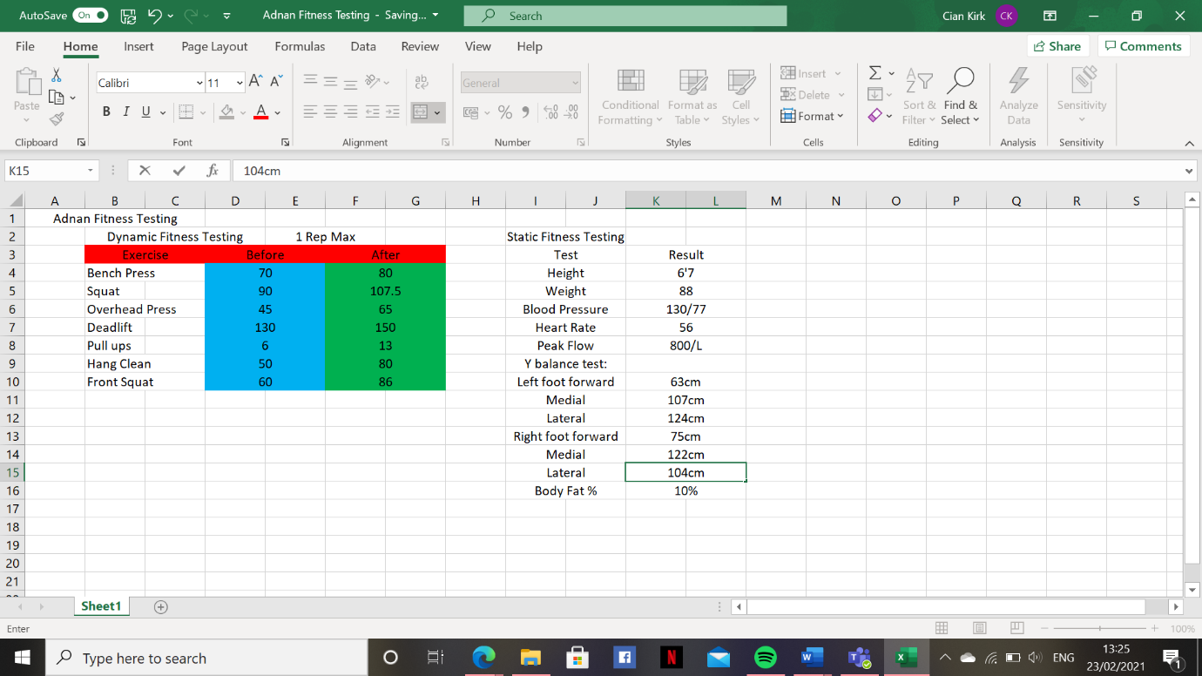

Training Programme: 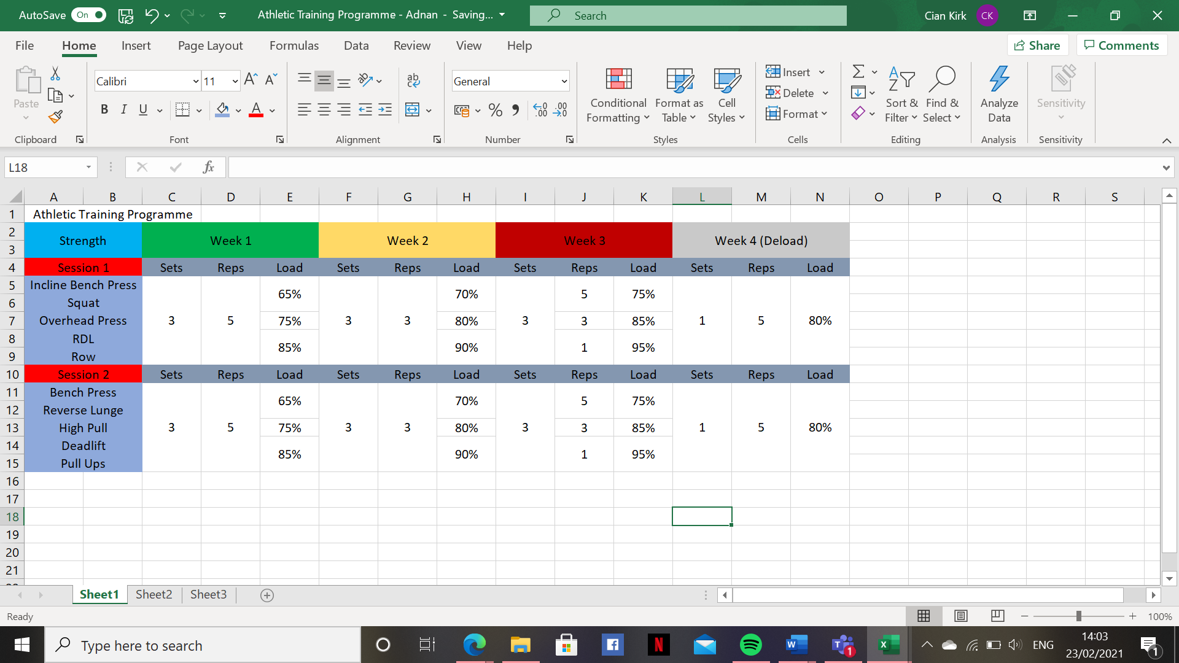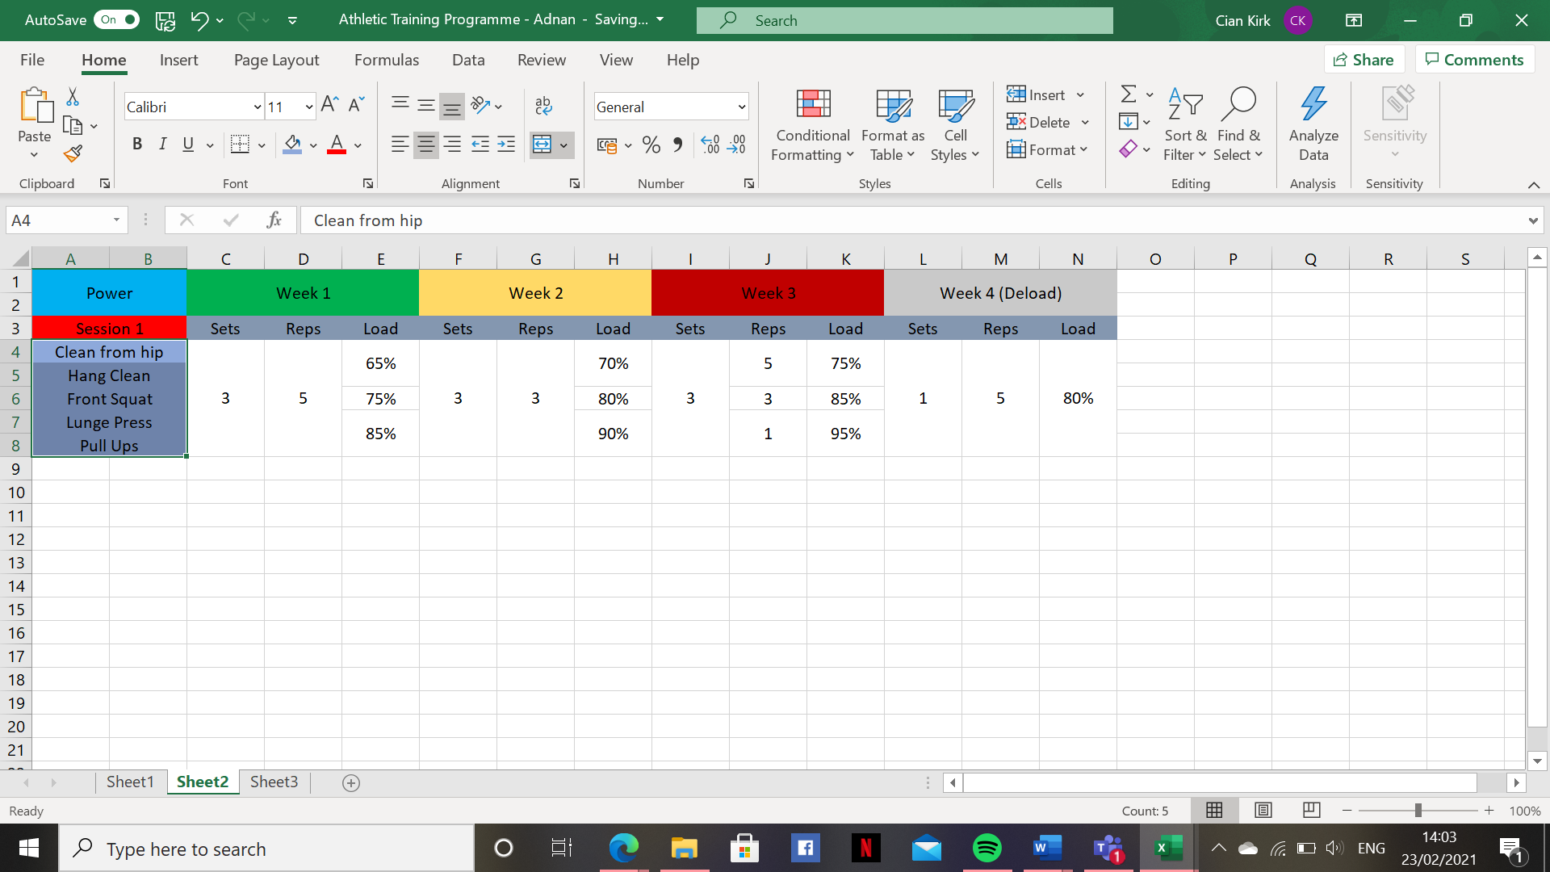

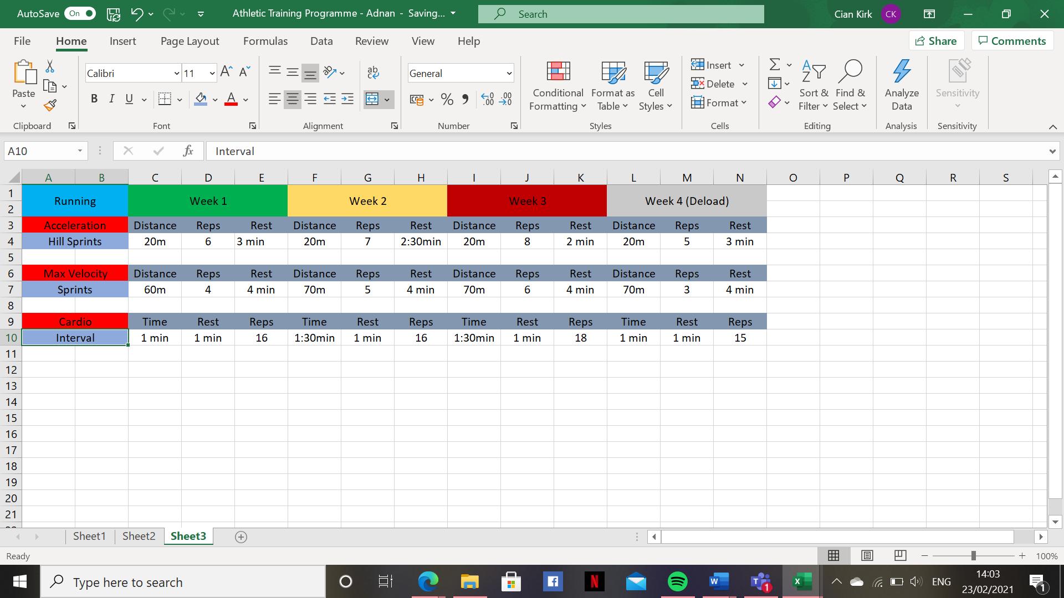

Lockdown Programme: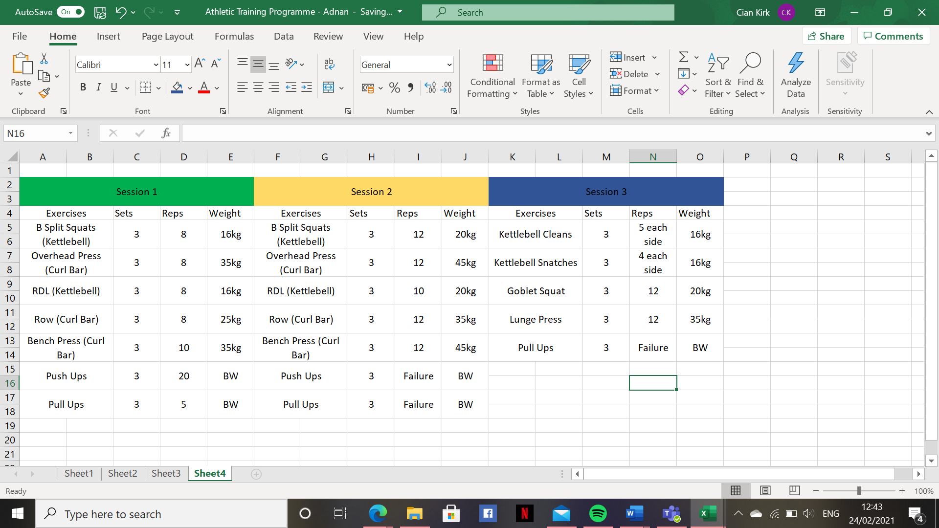

Interview Set Up:

