**REVISION QUESTIONS**

1. Cl2(g) +H2O(l) 🡪 Cl-(aq) + ClO-(aq) + 2H+(aq)

The addition of which substance would move the equilibrium to the right?

A Hydrogen

B Hydrogen chloride

C Sodium hydroxide

D Sodium chloride

1. During a redox process in acid solution, nitrate ions, NO3-(aq), are converted into

nitrite ions, NO2-(aq).

NO3- (aq) ⭢ NO2- (aq)

The numbers of H+(aq) and H2O(l) required to balance the ion-electron equation for the formation of 1 mol of NO2-(aq) are, respectively

A 2 and 1

B 1 and 3

C 1 and 1

D 3 and 2

1. Ammonia reacts with magnesium as shown.

3Mg(s) +2NH3(g) ⭢ (Mg2+)3(N3-)2(s) + 3H2(g)

In this reaction, ammonia is acting as:

A a reducing agent

B an oxidising agent

C a base

D an acid

1. The enthalpy changes for the formation of one mole of aluminium oxide and one mole of iron (III) oxide are shown below.

2Al(s) + 1½O2(g) ⭢ Al2O3(s) ∆H = ─1676kJmol-1

2Fe(s) + 1½O2(g) ⭢ Fe2O3(s) ∆H = ─825kJmol-1

Use the above information to calculate the enthalpy change for the reaction, in kJmol-1 :

Al(s) + ½Fe2O3(s) ⭢ ½Al2O3(s) + Fe(s)

1. The copper–chlorine cycle is an industrial process used to manufacture hydrogen.

There are four steps in the copper–chlorine cycle.

1. 4Cu + 4HCl → 4CuCl + 2H2

2. 4CuCl2 + 2H2O → 2Cu2OCl2 +4HCl

3. 2Cu2OCl2 → 4CuCl + O2

4. 8CuCl → 4CuCl2 + 4Cu

(a) Why does step 2 help to reduce the cost of manufacturing hydrogen?

(b) What is the overall equation for the copper–chlorine cycle?

(c) Explain why this process for production of hydrogen is considered to be

particularlycost effective**.**

1. Hydrogen can also be produced by cracking ethane.

C2H6 (g) 🡪 C2H4 (g) + H2 (g) Δ H = +138 kJ/mol

1. Explain why this process is process is carried out at high temperatures and at normal atmospheric pressure.
2. 100 tonnes of ethane produced 6 tonnes of hydrogen.

Calculate the % yield of this reaction.

1. **Ketones** exist in equilibrium with an **enol** isomer.

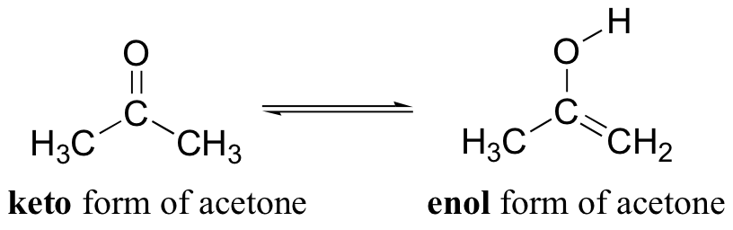

Use the bond energies in your data booklet to calculate the enthalpy change in kJmol-1 when one mole of gaseous acetone is converted to one mole of its gaseous enol isomer.

1. **What is the limiting reagent if 76.4 grams of**C2H3Br3**were reacted with 49.1 grams of**O2**?**

4C2H3Br3 + 11O2 → 8CO2 + 6H2O + 6Br2

1. Nitrogen monoxide gas, NO, combines with oxygen to form brown fumes of nitrogen dioxide according to the following equation.  
     
    2NO + O2 🡪 2NO2  
   calculate the volume of oxygen needed to react completely with 60cm3 of nitrogen monoxide? (Take the molar volume of NO and oxygen to be 22.4 l mol-1)
2. Balance the full redox equation:  
     
    ClO3- + I2 🡪 Cl- + IO3-