**FUN, FUN QUIZ TIME!**

1. The following equation represents a mixture at equilibrium. Which line in the table is true for the mixture after a further 2 hours of reaction?  
     
    2SO2(g) + O2(g) ↔ 2SO3(g)

|  |  |  |
| --- | --- | --- |
|  | **Rate of forward reaction** | **Rate of back reaction** |
| **A** | Decreases | Decreases |
| **B** | Increases | Increases |
| **C** | Unchanged | Decreases |
| **D** | Unchanged | Unchanged |

1. During a redox process in acid solution, iodate ions, IO3 − (aq), are converted into iodine, I2(aq).   
     
    IO3 − (aq) → I2(aq)   
     
   The numbers of H+ (aq) and H2O(l) required to balance the ion-electron equation for the formation of 1 mol of I2(aq) are, respectively   
     
   A 3 and 6   
   B 6 and 3   
   C 6 and 12   
   D 12 and 6.

1. The production of hydrogen chloride from hydrogen and chlorine is exothermic.   
     
    H2(g) + Cl2(g) → 2HCl(g)   
     
   Using bond enthalpy values, calculate the enthalpy change, in kJ, for the reaction.

1. Given the following data:   
   ΔHf(CH4) = -74.8 kJmol-1,   
   ΔHf(CH3Cl) = -134.5 kJmol-1,   
   ΔHf(HCl) = -92.3 kJmol-1;

Calculate ΔH for the reaction

CH4(g) + Cl2(g) 🡪 CH3Cl(g) + HCl(g)

1. 2-Methylpropan-1-ol can also be converted to produce diesel and jet fuel.   
     
   The first step in the process is the production of 2-methylpropene.   
     
   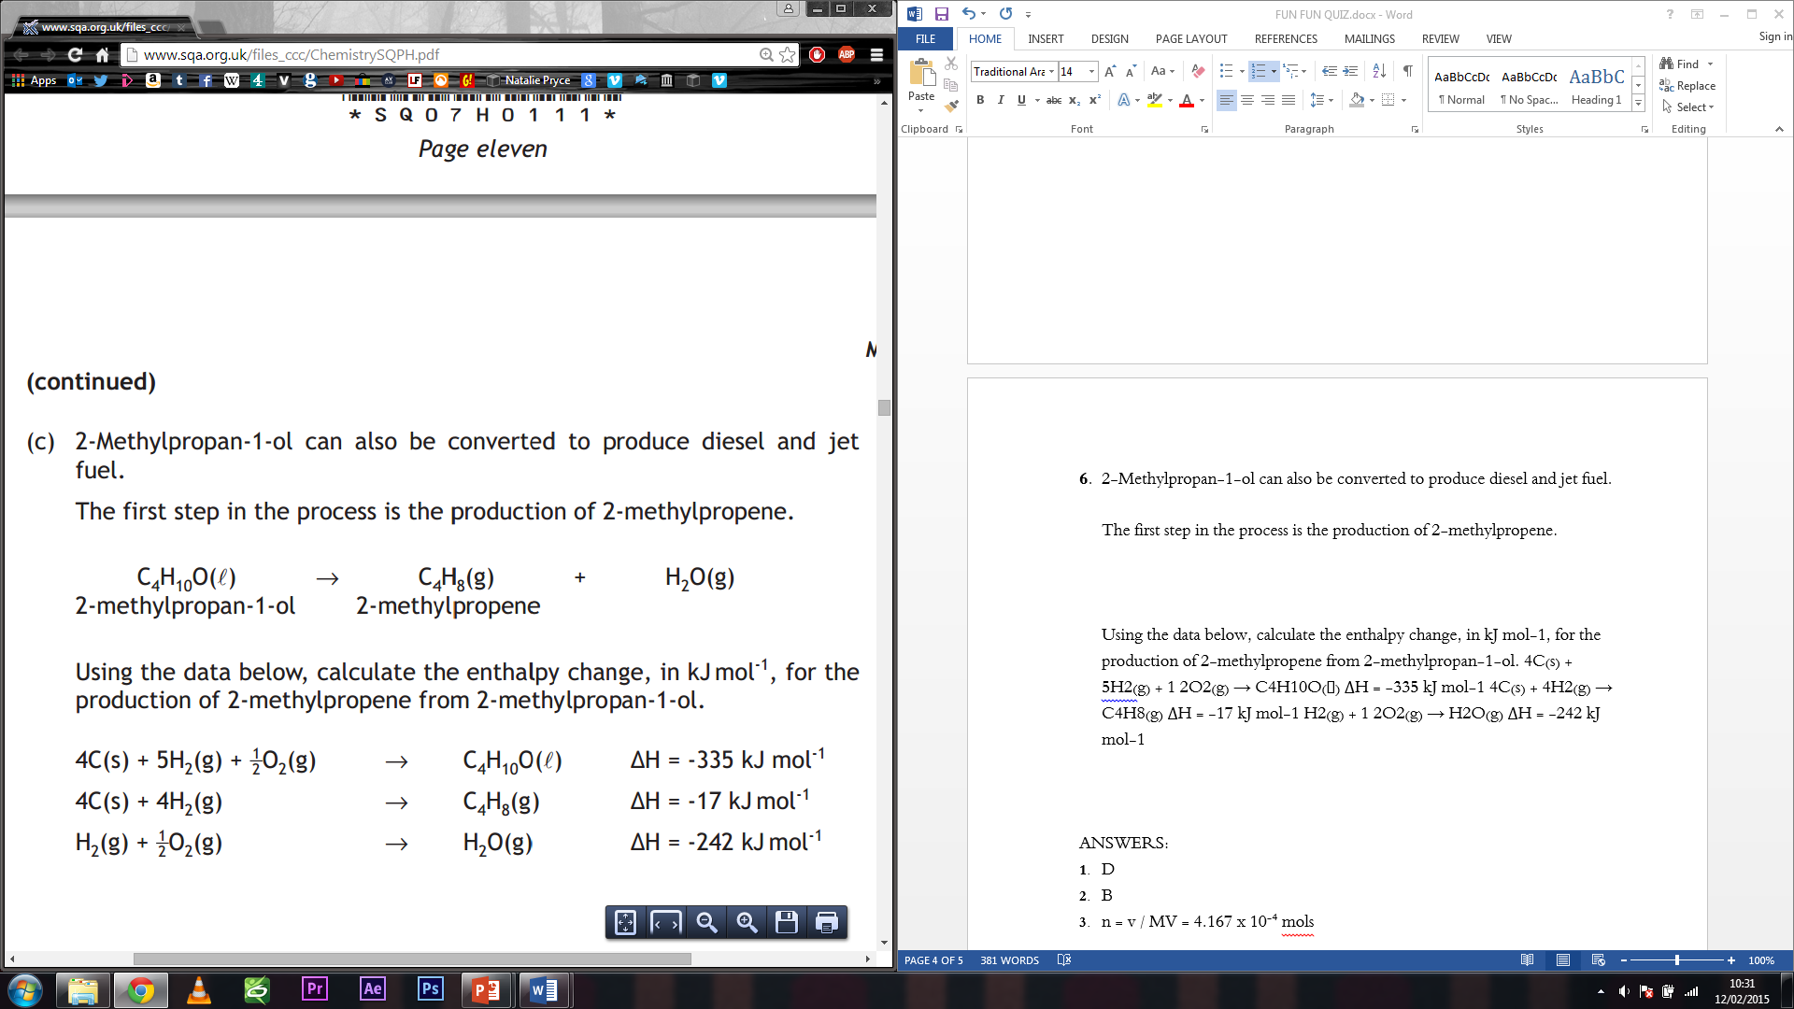

Using the data below, calculate the enthalpy change, in kJ mol-1, for the production of 2-methylpropene from 2-methylpropan-1-ol.   
  


1. The concentration of nitrite ions in the water supply was determined by titrating water samples with acidified permanganate solutions.  
   During the reaction the nitrite ion is oxidised to the nitrate ion.   
   Complete the ion-electron equation for the oxidation of the nitrite ion.

NO2 − (aq) → NO3 − (aq)

1. An average of 21·6 cm3 of 0·015 mol l-1 acidified permanganate solution was required to react completely with the nitrite ions in a 25·0 cm3 sample of water.   
   The equation for the reaction taking place is

2MnO4− (aq) + 5NO2− (aq) + 6H+ (aq) → 2Mn2+(aq) + 5NO3− (aq) + 3H2O(l)   
  
 Calculate the nitrite ion concentration, in mol l-1, in the water.

1. Some oils are used to make soap. The oil, triolein, was reacted with sodium hydroxide.

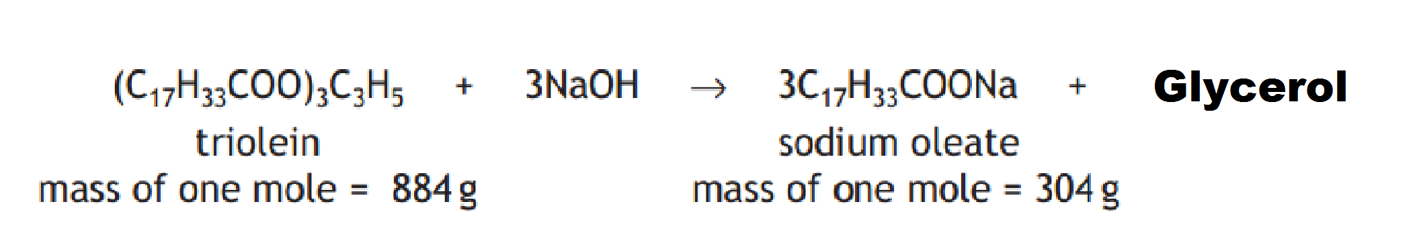

The experiment produced 1·28g of sodium oleate. 5·0g of triolein was dissolved in ethanol and placed in a test tube with excess sodium hydroxide. Calculate the percentage yield.

1. The production of urea involves two reversible reactions.   
     
   In the first reaction ammonium carbamate is produced.   
     
    2NH3(g) + CO2(g) ↔ H2NCOONH4(g)   
     
   In the second reaction the ammonium carbamate decomposes to form urea.   
     
    H2NCOONH4(g) ↔ (NH2)2CO(g) + H2O(g)   
     
   A chemical plant produces 530 tonnes of urea per day. Calculate the theoretical mass, in tonnes, of ammonia required to produce 530 tonnes of urea.
2. An undesirable side reaction of an industrial process is the production of biuret, a compound that can burn the leaves of plants.   
     
   2(NH2)2CO(aq) ↔ NH2CONHCONH2(aq) + NH3(g)   
    biuret   
     
   State why having an excess of ammonia in the reactors will decrease the amount of biuret produced.
3. In the separator the ammonium carbamate from the reactors decomposes to form ammonia and carbon dioxide.   
     
    NH2COONH4(aq) ↔ 2NH3(g) + CO2(g)   
     
   Explain clearly why a low pressure is used in the separator.
4. The recommended daily allowance of methionine for an adult is 15mg per kg of body mass. Tuna contains 755mg of methionine per 100g portion. Calculate the mass, in grams, of tuna that would provide the recommended daily allowance of methionine for a 60kg adult.
5. Mixtures of amino acids can be separated using paper chromatography. On a chromatogram, the retention factor, Rf , for a substance can be a useful method of identifying the substance.

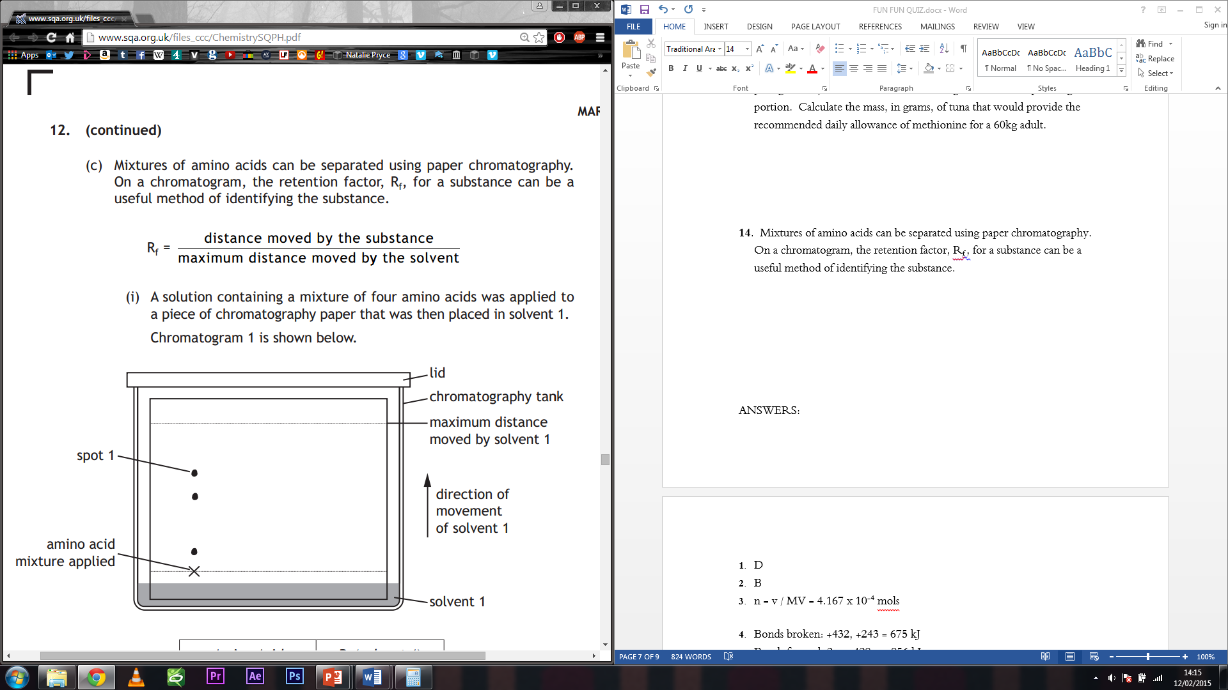

A solution containing a mixture of four amino acids was applied to a piece of chromatography paper that was then placed in solvent 1.   
Chromatogram 1 is shown below.  
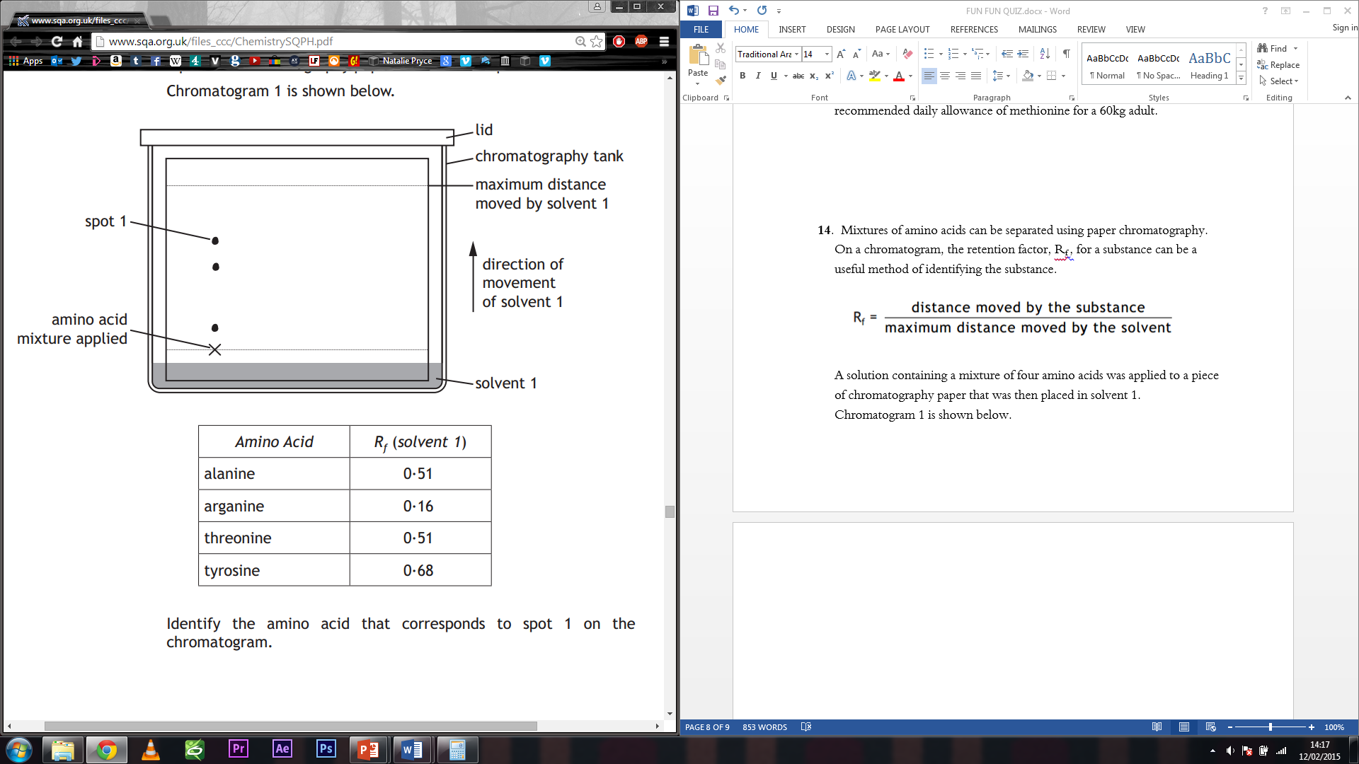  
  
Identify the amino acid that corresponds to spot 1 on the chromatogram.

1. **CONTINUED**   
   The chromatogram was dried, rotated through 90º and then placed in solvent 2. Chromatogram 2 is shown below.  
     
   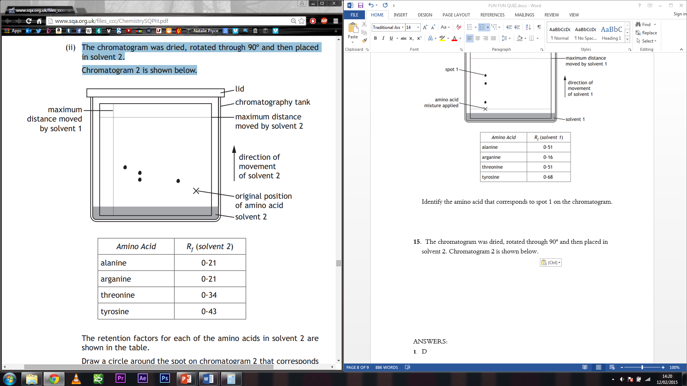  
     
   The retention factors for each of the amino acids in solvent 2 are shown in the table.   
     
   Draw a circle around the spot on chromatogram 2 that corresponds to the amino acid alanine.

1. **CONTINUED**  
   Explain why only three spots are present in chromatogram 1 while four spots are present in chromatogram 2.
2. Write the balanced half reactions of the following reaction:  
     
    H+ + 2H2O + 2MnO4- + 5SO2 http://www.chemistry.wustl.edu/~coursedev/Online%20tutorials/arrow.gif 2Mn2+ + 5HSO4- in acidic solution
3. The highest oxidation state of chlorine is present in:

A HClO

B HClO2

C HClO3

D HClO4

1. Iodine was added to 50 cm3 of two immiscible solvents X and Y in a separating funnel. After shaking, the following equilibrium was established.   
     
   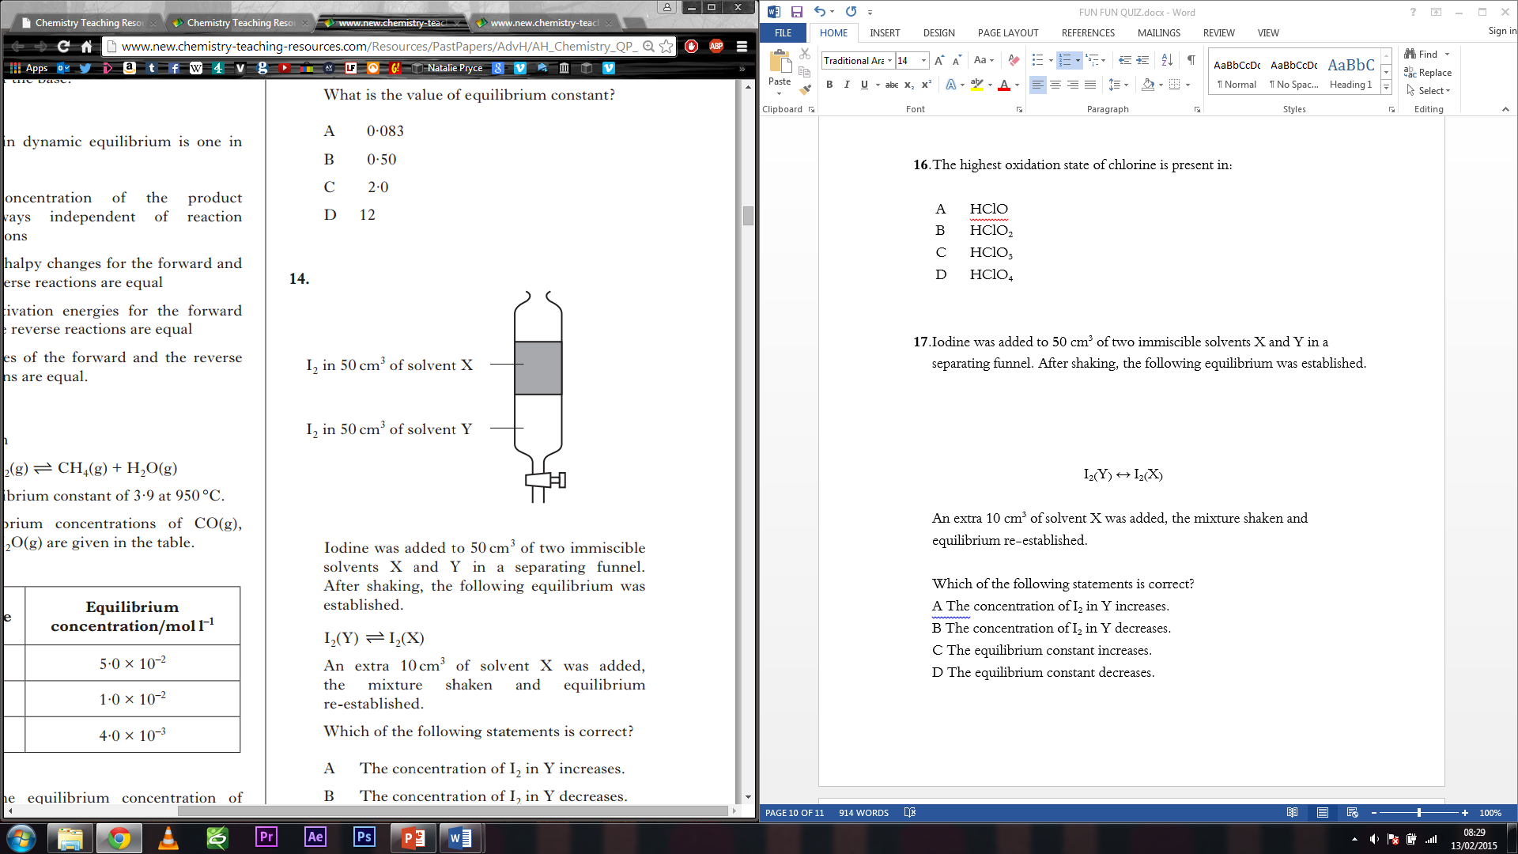 I2(Y) ↔ I2(X)   
   An extra 10cm3 of solvent X was added, the mixture shaken and equilibrium re-established.   
     
   Which of the following statements is correct?   
     
   A The concentration of I2 in Y increases.   
   B The concentration of I2 in Y decreases.   
   C The equilibrium constant increases.   
   D The equilibrium constant decreases.
2. Using the data from the table below calculate the standard enthalpy change, in kJ mol-1, for the following reaction.  
     
    2NaHCO3(s) 🡪 Na2CO3(s) + CO2(g) + H2O(g)

|  |  |
| --- | --- |
| **Compound** | **Standard enthalpy of formation /kJ mol-1** |
| NaHCO3(s) | -948 |
| Na2CO3(s) | -1131 |
| H2O(g) | -242 |
| CO2(g) | -394 |