

Chemistry in Society

Worksheet 4

1. 4g of potassium chloride, KCl, was dissolved in 50cm3 of water. The initial temperature of the water was 20.4oC and the highest temperature of solution was 18.8oC.

Calculate the enthalpy of solution.  
  
ΔT = 1.6 oC

Eh = cm ΔT = 4.18 x 0.05 x 1.6 = 0.3344kJ

FM of KCl = 74.55g

0.3344/4 = 0.0836 kJ for 1g

0.0836 x 74.55 = 6.232kJmol-1

ΔH of solution of KCl = 6.232kJmol-1

N =mass/FM = 4/74.55 = 0.053 moles

0.33kJ 🡪 0.053mol

6kJ 🡪 1mol

1. 3.03g of potassium nitrate, KNO3, was dissolved in 100cm3 of water. The initial temperature of the water was 17.5oC and the highest temperature of solution was 15oC.

Calculate the enthalpy of solution.  
  
ΔT = 2.5 oC

Eh = cm ΔT = 4.18 x 0.1 x 2.5 = 1.045kJ

FM of KNO3 = 101.11g

1.045/3.03 = 0.34488 kJ for 1g

0.34488 x 101.11 = 34.87kJmol-1

ΔH of solution of KNO3 = 34.87kJmol-1

1. A 250ml solution of 2.25moldm-3 HCl was neutralised by 250ml of NaOH solution. The temperature increased by 33oC. Calculate the enthalpy of neutralisation.  
     
     
   HCl + NaOH 🡪 NaCl + H2O  
     
   Eh = -cm ΔT = 4.18 x 0.5 x 33 = -68.97kJ (exothermic)  
   n of moles of HCl = v x c = 0.25 x 2.25 = 0.56 moles  
   1:1 ratio  
   n of moles of water = 0.56 moles  
   ΔH = -68.97/0.56 = -123.16kJmol-1
2. Calculate the enthalpy change for the following reaction:  
     
   enthalpy of formation of ammonia to be -45.9kJmol-1, the enthalpy of formation of nitrogen monoxide 90.29kJmol-1 and the enthalpy of formation of water to be -285.83kJmol-1.  
     
   ΔH = ΣnΔHfoproducts - ΣnΔHforeactants  
   ΣnΔHfoproducts = (4 x 90.29) + (6 x -285.83) = -1353.82  
   ΣnΔHforeactants = (4 x -45.9) = -183.6  
     
   ΔH = -1353.82 – (-183.6) = -1170.22 kJmol-1
3. Calculate the enthalpy change for the combustion of propane:  
     
   -285.83 kJ/mol  
     
   ΔH = ΣnΔHfoproducts - ΣnΔHforeactants  
   ΣnΔHfoproducts = (3 x -393.5) + (4 x -285.83) = -2323.82  
   ΣnΔHforeactants = -104.7  
     
   ΔH = -2323.82– (-104.7) = -2219 kJmol-1
4. Calculate the enthalpy change for the combustion of propane if 33g of propane were used.  
     
   FM of propane = 44g  
   n of moles of propane = mass/FM = 33/44 = 0.75  
     
   ΔH = -2219 kJmol-1 x 0.75 = -1664.34 kJ
5. Calculate the enthalpy change for the complete combustion of carbon using the equations:
6. Find the ΔH of:  
    ΔH = -537 kJ  
    ΔH = +52 kJ  
     
    ΔH = +680 kJ  
     
     
   2 x ( ΔH = -537 kJ)   
     
   = ΔH = -1074 kJ  
     
    ΔH = -52 kJ  
     
   2 x ( ΔH = -680 kJ)   
     
   = ΔH = -1360 kJ  
     
   total = ΔH = -2486 kJ
7. Find the ΔH of:  
    ΔH = -298 kJ  
    ΔH = +198 kJ  
     
     
    ΔH = -596 kJ  
    ΔH = -198 kJ  
    ΔH = -794 kJ
8. Calculate the ΔH for the following reaction, using average bond enthalpies, assuming all compounds are in their gaseous states:  
     
     
   ΔH = Σn(bonds broken) – Σm(bondsformed)  
     
   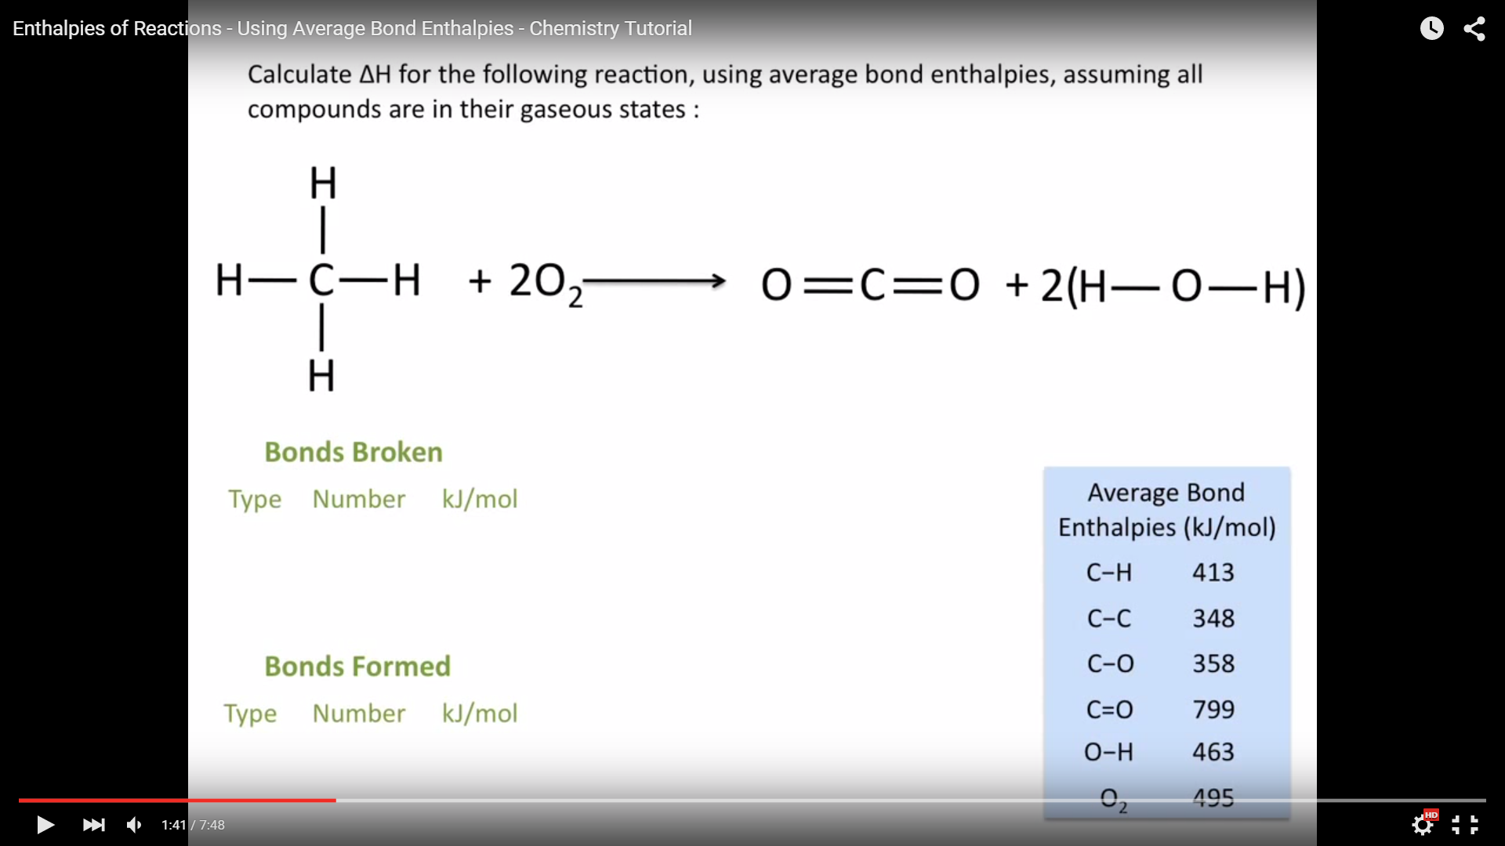  
     
   Bonds broken:  
   4 x C-H  
   4 x 413 = 1652  
   2 x O2   
   2 x 495 = 990  
     
   Bonds formed:  
   2 x C=O  
   2 x 799 = 1598  
   4 x O-H   
   4 x 463 = 1852  
     
   ΔH = (1652+990) – (1598+1852)   
   ΔH = (2642) – (3450)  
   ΔH = -808 kJ/mol
9. Calculate ΔH for the following reaction, using average bond enthalpies, assuming all compounds are in their gaseous states:  
     
   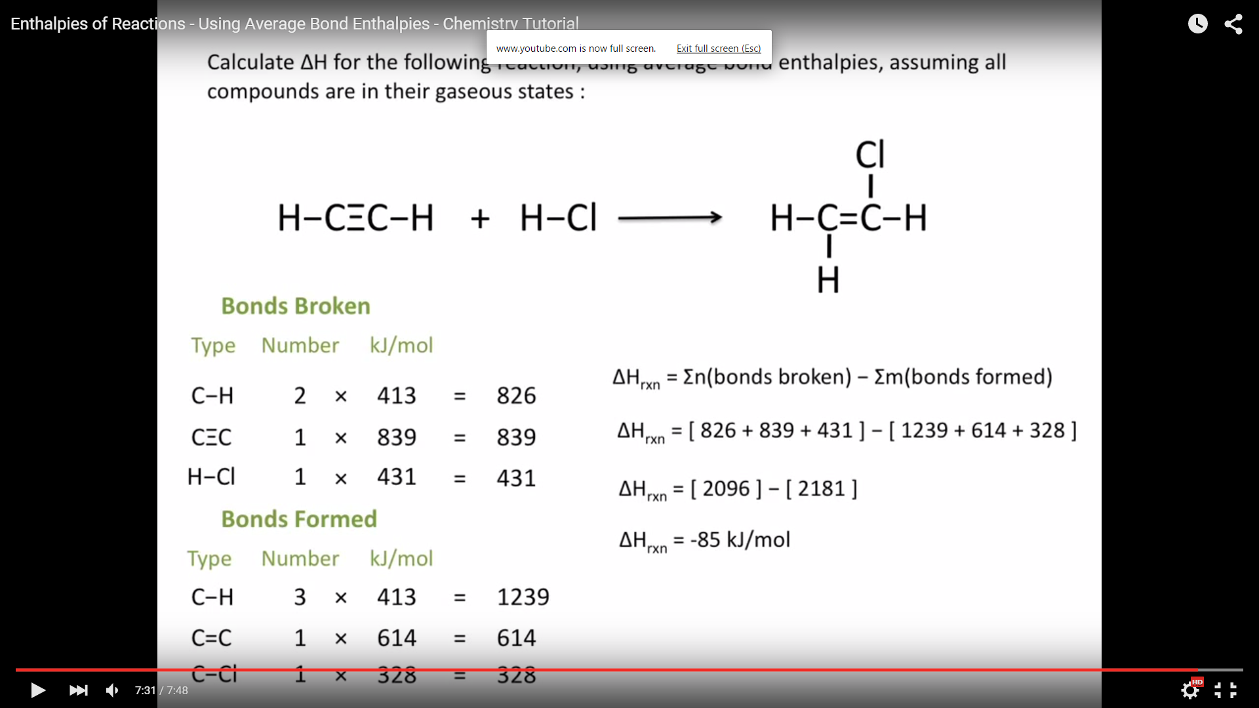  
     
     
   ΔH = Σn(bonds broken) – Σm(bondsformed)  
     
   Bonds broken:  
   2 x C-H  
   2 x 413 = 826  
   1 x C=C  
   1 X 839 = 839  
   1 x H-Cl  
   1 x 431 = 431  
     
   Bonds formed:  
   3 x C-H  
   3 x 413 = 1239  
   1 x C=C  
   1 x 614 = 614  
   1 x C-Cl  
   1 x 328 = 328  
     
   ΔH = (826+839+431) – (1239+614+328)   
   ΔH = (2094) – (2186)  
   ΔH = -92 kJ/mol