**Uncertainties, Moles, amounds of substances in equations and limiting reactants**

Score: /10

Green: 8+

Amber: 6-8

Red: 5<

Red: 0-6

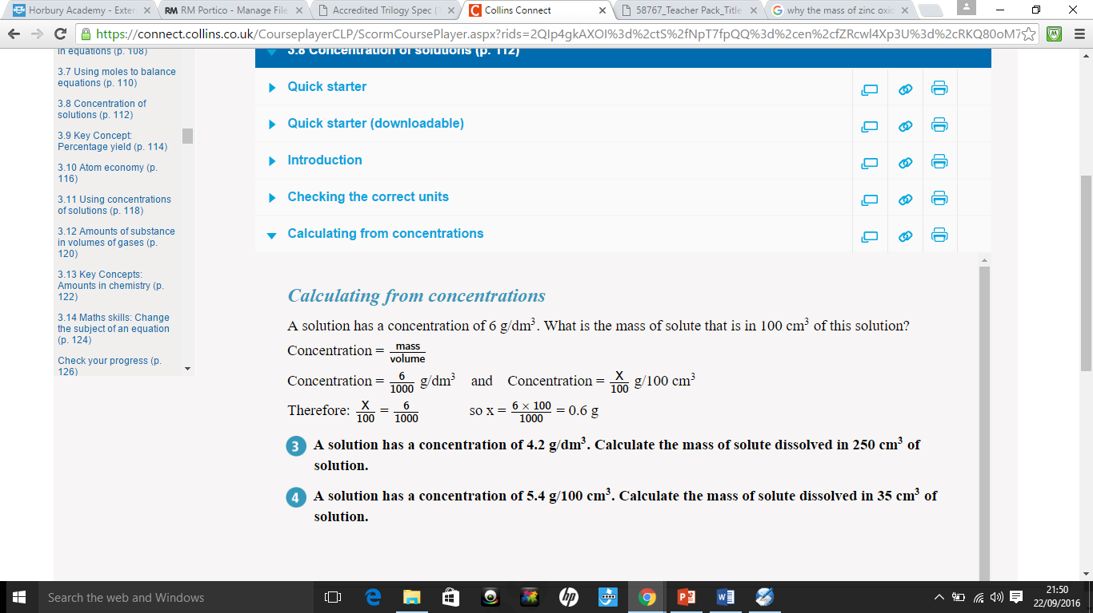

|  |  |
| --- | --- |
| **Question** | **Answer** |
| 1. Give the unit when measuring Moles |  |
| 1. Work out the mass of one mole of H2O.   [Relative atomic mass of H is 1, relative atomic mass of O is 16] |  |
| 1. A burette used to measure volumes of liquids has an uncertainty of ±0.05 cm3. Emma uses it to measure 25.30 cm3 of water. How much water could Emma actually have measured? |  |
| 1. A set of measurements has a range of 0.60 cm and a mean of 7.5 cm. What is the percentage uncertainty? |  |
| 1. Match the descriptions to the key words.  |  |  | | --- | --- | | 1. The difference between the lowest and highest value | a.Accuracy |  |  |  | | --- | --- | | 2.The range of measurements divided by the mean, multiplied by 100 | b.Mean |  |  |  | | --- | --- | | 3.How close a measurement is to the true value | c.Range |  |  |  | | --- | --- | | 4.Add up all the values and divide by the number of values | d.Percentage uncertainty | |  |
| 1. The number of atoms, molecules or ions in a mole of a given substance is the Avogadro constant. Give the value for the Avogadro constant. |  |
| 1. Mg + 2HCl MgCl2 + H2   In the above equation, how many moles of Magnesium react with two moles of Hydrochloric acid? |  |
| 1. Calculate the mass of half a mole of water. |  |
| 1. In a chemical reaction involving two reactants, it is common to use an excess of one of the reactants. Explain why. |  |
| 1. 10g of copper are burnt in oxygen according to the equation:   2Cu + O2 🡪 2CuO  How many moles of copper oxide are produced? |  |